|  |  |  |  |  |
| --- | --- | --- | --- | --- |
|  |  | | |  |
|  |  | | |  |
|  | Stowable Steering and Deployable Tray  <<Feature>>  (F002870) | | |  |
|  |  | | |  |
| Document Type | **Feature Document (FD)** | | |  |
| Template Version | **6.0b / FFSD 7.1** | | |  |
| SysML Report Template Version | **O Beta (7/25/2019)** | | |  |
| Document ID | **ffst01.10_featuredocument_sysmlreporttemplate** | | |  |
| Document Location |  | | |  |
| Document Owner | **Tok Lau (TLAU4),John Moore (jmoor457), Murty Richard (O.) (RMURTY)** | | |  |
| Document Revision | **FD0** | | |  |
| Document Status | **Draft** | | |  |
| Date Issued | **2021-02-22** | | |  |
| Date Revised | **2021-02-22** | | |  |
| Document Classification | GIS1 Item Number: | **27.60/35** | |  |
| GIS2 Classification: | **Confidential** | |
|  | | | | |
|  | | | | |
| Document Approval | | | | |
| Person | Role | | Email Confirmation | Date |
|  |  | |  |  |
|  |  | |  |  |

**Auto-Generated by MagicDraw**

Printed Copies Are Uncontrolled

# Disclaimer

**This document contains Ford Motor Company Confidential information. Disclosure of the information contained in any portion of this document is not permitted without the expressed, written consent of a duly authorized representative of Ford Motor Company, Dearborn, Michigan, U.S.A.**

**Copyright, Ó 2016 Ford Motor Company**

This document contains information developed and accumulated by and for FORD MOTOR COMPANY. As such, it is a proprietary document, which, if disseminated to unauthorized persons, would provide others with restricted information, data, or procedures not otherwise available, exposing the FORD MOTOR COMPANY to potential harm.

Employees and suppliers having custody of this specification or authorized to use it must be cognizant of its proprietary nature and ensure that the information herein is not made available to unauthorized persons.

FORD MOTOR COMPANY reserves the right to protect this work as an unpublished copyrighted work in the event of an inadvertent or deliberate unauthorized publication. FORD MOTOR COMPANY also reserves its rights under copyright laws to protect this work as a published work.

This document or portions thereof shall not be distributed outside FORD MOTOR COMPANY without prior written consent. Refer all questions concerning disclosure to the author(s) or to any duly authorized representative of Ford Motor Company.

# Contents

1.1.2 Decomposition of Functional Safety Requirement 13

Disclaimer 22

Contents 23

2 Introduction 26

2.1 Document Purpose 26

2.2 Document Scope 26

2.3 Document Audience 26

2.3.1 Stakeholder List 26

2.4 Document Organization 26

2.4.1 Document Context 26

2.4.2 Document Structure 27

2.5 Document Conventions 27

2.5.1 Requirements Templates 27

3 Feature Overview 28

3.1 Purpose and Description of Feature 28

3.2 Feature Variants 28

3.2.1 Regions & Markets 29

3.3 Input Requirements 29

3.3.1 Legal Requirements 30

3.3.2 Trustmark Requirements 30

3.3.3 Industry Standards 30

3.3.4 Attribute Requirements 30

3.4 Lessons Learned 30

3.5 Assumptions 31

3.6 References 31

3.6.1 Ford Documents 32

3.6.2 External Documents and Publications 32

3.7 Glossary 33

3.7.1 Parameters / Values 33

4 Feature Context 34

4.1 Feature Context Diagram 34

4.2 List of Influences 34

5 Feature Modeling 36

5.1 Operation Modes and States 36

5.2 Use Cases 38

5.2.1 Use Case Diagram 38

5.2.2 Actors 39

5.2.3 Use Case Descriptions 39

5.3 Driving and Operation Scenarios 43

5.4 Decision Tables 45

6 Feature Requirements 46

6.1 Functional Requirements 46

6.1.1 Error Handling 47

6.2 Non-Functional Requirements 47

6.2.1 Safety 47

6.2.2 Security 47

6.2.3 Reliability 47

6.3 HMI Requirements 47

6.4 Other Requirements 48

6.4.1 Design Requirements 48

6.4.2 Manufacturing Requirements 48

6.4.3 Service Requirements 48

6.4.4 After Sales Requirements 48

6.4.5 Process Requirements 48

6.4.6 Uncategorized Requirements 49

7 Functional Safety 50

7.1 System Behaviors for HARA 50

7.2 Safety Assumptions 50

7.3 Safety Goals 51

7.4 Functional Safety Requirements 53

7.4.1 Safety Goal: 53

7.4.2 Derivation of Functional Safety Requirements on Assumptions 55

7.5 ASIL Decomposition of Functional Safety Requirements 56

8 Architecture 57

8.1 Functional Architecture 57

8.1.1 List of Functions 57

8.2 Logical Architecture 58

8.2.1 Logical Interfaces 59

9 Open Concerns 61

10 Revision History 62

11 Appendix 63

11.1 Definitions 63

11.2 Abbreviations 63

**List of Figures**

Figure 1. 12

Figure 2: 28

Figure 3: - 28

Figure 4: 34

Figure 5: 36

Figure 6: 38

Figure 7:  55

Figure 8: 57

Figure 9: 58

**List of Tables**

Table 1: Features described in this FD 26

Table 2: Feature Variants 29

Table 3: Regions & Markets 29

Table 4: Ford internal Documents 32

Table 5: Ford internal Documents *(not specified in SysML model)* 32

Table 6: External documents and publications 32

Table 7: External documents and publications *(not specified in SysML model)* 33

Table 8: Parameters / Values used in this document *(Not supported by MagicDraw report generation)* 33

Table 9: List of Influences 35

Table 10: Operation Modes and States on 36

Table 11: Transitions between Operation Modes and States on 38

Table 12: List of Actors 39

Table 13: System Behaviors for HARA 50

Table 14: Functional Safety Assumptions 51

Table 15: Functional Safety Goals 53

Table 16: List of Functions 58

Table 17: List of Functions on 58

Table 18: Feature Interactions 59

Table 19: Feature Interactions on 59

Table 20: Open Concerns *(Not supported by MagicDraw report generation)* 61

Table 21: Definitions used in this document 63

Table 22: Abbreviations used in this document 64

# Introduction

## Document Purpose

A Feature Document (FD) document specifies **what** the feature shall do and how it shall behave from customer perspective. It should also provide reasoning and background **why** we have the feature in the vehicle.

The FD also serves as an Item Definition as defined by ISO26262 for those features, which follow the Ford Functional Safety process.

To get more information about the concept of feature, function and component level abstraction refer to the [Ford RE Wiki](http://wiki.ford.com/display/RequirementsEngineering/Requirements+Engineering+for+SW+Enabled+Features). For details on the Ford Functional Safety (ISO26262) process refer to the [Ford Functional Safety Sharepoint](https://pd3.spt.ford.com/sites/GlobalFunctionalSafety/Pages/default.aspx).

## Document Scope

This Feature Document (FD) specifies the following features:

|  |  |  |  |
| --- | --- | --- | --- |
| **Feature ID** | **Feature Name** | **Owner** | **Reference** |
| F002870 | Stowable Steering and Deployable Tray  (Program(s): GE2--MY2024) | Tok Lau (TLAU4),John Moore (jmoor457), Murty Richard (O.) (RMURTY) |  |

Table 1: Features described in this FD

## Document Audience

The FD is written by the feature owner of Tok Lau (TLAU4),John Moore (jmoor457), Murty Richard (O.) (RMURTY). All Stakeholders, i.e., all people who have a valid interest in the feature should read and, if possible, review the FD. It needs to be guaranteed, that all stakeholders have access to the currently valid version of the FD.

**#Hint:** The FD template has the IP Classification “Proprietary” by default. IP Classification “Confidential” might be required in some cases, e.g. by Ford Functional Safety.

### Stakeholder List

For the latest list of stakeholder of the feature and their influence refer to <Put VSEM Link here>.

**#Hint:** Refer to [Ford RE Wiki – Stakeholder List](http://wiki.ford.com/display/RequirementsEngineering/Stakeholder+Analysis) on how to create a stakeholder list. The stakeholder list should be stored in VSEM in the pseudo folder “General Data Artifacts” of the corresponding feature.

## Document Organization

### Document Context

Refer to the [Specification Structure page](http://wiki.ford.com/display/RequirementsEngineering/Specification+templates) in the [Ford RE Wiki](http://wiki.ford.com/display/RequirementsEngineering/Requirements+Engineering+for+SW+Enabled+Features) to understand how the FD relates to other Ford Requirements Documents and Specifications.

### Document Structure

The structure of this document is explained below:

**Section 1** – Introduction how to use this document including responsibilities and requisite documents. Explains the terminology. Gives a clarification of the definitions, concepts and abbreviations used in the document.

**Section 2** – Feature Description. States briefly the background and the purpose of the feature, feature variants and corresponding regions and markets. Also includes input requirements, assumptions and constraints.

**Section 3** – Feature Context describes all external entities, which have an influence on the feature.

**Section 4** – Feature Modeling. Contains Use Case, Driving Scenarios, State Charts to describe the functional behavior of the feature.

**Section 5** – Safety. Lists System Behaviors and Safety Goals of the feature.

**Section 6** – Feature Requirements. Lists functional and non-functional requirements of the feature.

**Section 7** – Architecture. Shows the coarse architecture, which the feature requirements are deployed to. Describes the elements and the boundary of the feature as well as the decomposition and distribution of associated functions.

**Section 8** – List of Open Concerns

**Section 9** – Document Change History including a list of new or modified requirements. The requirements in this document are tagged, and this section contains different types of tables listing all, new, or changed requirements by their title and page no.

**Section 10** – Appendix

**#Hint:** All sections are mandatory, unless explicitly marked by the tag “#Classification” as “optional” or as applicable e.g. to certain domains like “Functional Safety”.

## Document Conventions

### Requirements Templates

Each requirement, use case or scenario in this specification shall follow the corresponding template given in the document template *Specification_Macros.dotm* at [RE Wiki - Specification Templates](http://wiki.ford.com/display/RequirementsEngineering/Specification+templates?src=contextnavpagetreemode).

#### Identification of requirements

#### Requirements Attributes

The templates provided by *Specification_Macros.dotm* define a list of attributes for each requirement. This helps to classify the requirement. The attributes are explained at [RE Wiki - Requirements Attributes](http://wiki.ford.com/display/RequirementsEngineering/Requirements+Attributes?src=contextnavpagetreemode).

## References

### Ford Documents

List here all Ford internal documents, which are directly related to the feature.

| **Reference** | **Title** | **Doc. ID** | **Document Location** | **Revision** |
| --- | --- | --- | --- | --- |
|  |  |  |  |  |

Table 5: Ford internal Documents *(not specified in SysML model)*

### External Documents and Publications

The list of external documents could include books, reports and online sources.

**#Hint:** You may refer to [IEEE Citation Reference](http://www.ieee.org/documents/ieeecitationref.pdf) on how to format a reference.

| **Reference** | **Document / Publication** | **Document Location** |
| --- | --- | --- |
|  |  |  |

Table 7: External documents and publications *(not specified in SysML model)*

## Glossary

**#Hint**: Terms, concepts and abbreviations used in the document shall be defined and illustrated here. Note that changes to terms and/or concepts described in this section tend to cause major updates to this document.

The tables below have feature specific definitions and abbreviations. For additional, non-feature specific terms please refer to the [RE Glossary](http://wiki.ford.com/display/RequirementsEngineering/Glossary?src=contextnavpagetreemode)

See Appendix for Definitions and Abbreviations.

### Parameters / Values

| **Name** | **Description** | **Range / Resolution** |
| --- | --- | --- |
|  |  |  |

Table 8: Parameters / Values used in this document *(Not supported by MagicDraw report generation)*

# Feature Overview

## Purpose and Description of Feature

**#Hint:** Some descriptive text to explain the purpose and functionality of the feature.

Stowable Steering wheel with deployable work surface is to enable customers to make use of their fragmented time, to cope with their busy, always changing schedule and allow themselves to enjoy a piece of me-time or manage business needs.

For right now, this does not extend from drive my vehicle because it is covered by an another feature/function

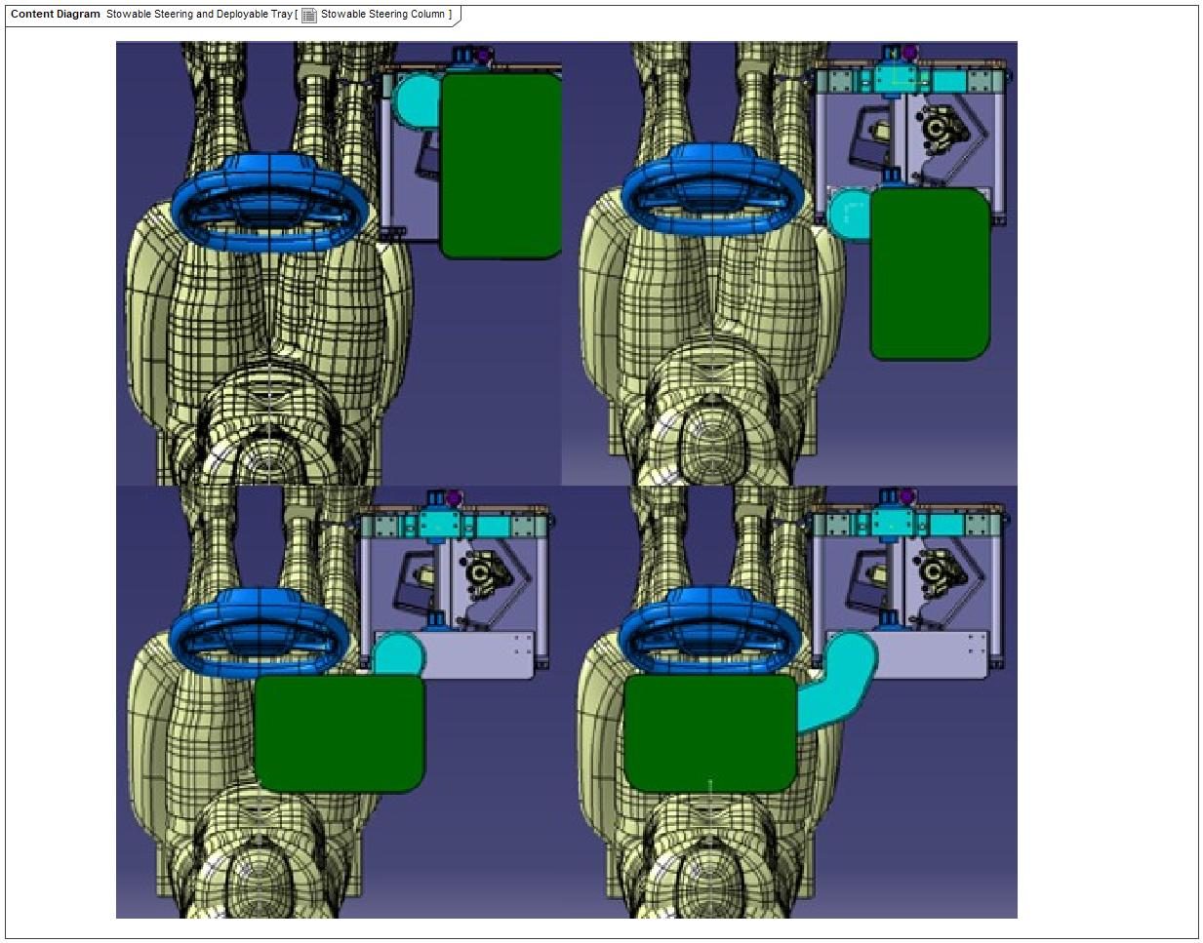

Figure 3: Stowable Steering Column - Folding Tray Concept

## Feature Variants

**#Hint:** Definitions for different variants of the feature (if applicable). Give each variant a descriptive name by which it can be referenced further on in the document. If no variant exists, state “No Feature Variants”.

The Variant Description should give a short informative text which describes the variants of the feature.

|  |  |  |
| --- | --- | --- |
| **Variant Name** | **Variant Description** | **Remarks** |
| **Ford Variant** | The Ford Variant varies from the Lincoln Variant in the look and feel and materials used. |  |
| **Lincoln Variant** |  |  |

Table 2: Feature Variants

### Regions & Markets

**#Hint:** Description of purpose and functionality of the feature. If there is no variant, give feature name in first column.

|  |  |  |  |  |  |  |
| --- | --- | --- | --- | --- | --- | --- |
| **Market /**  **Region**  Variant Name | **North America** | **South America** | **Europe** | **Middle East/Africa** | **Asia / Pacific** | **China** |
| **Ford Variant** | Optional | No | Mandatory | No | No | No |
| **Lincoln Variant** | Mandatory | No | No | No | No | Mandatory |

Table 3: Regions & Markets

## Input Requirements

**#Hint:** List all input requirements, which are relevant for the feature. Typically, attribute requirements, legal requirements as well as national and international standards have to be considered.

### Legal Requirements

* : Compliance with FMVSS101
  + The Feature shall comply with FMVSS101.

### Trustmark Requirements

No Trustmark Requirements specified.

### Industry Standards

* : ISO 26262
  + The system should be developed according to Ford's implementation of Functional Safety.

### Attribute Requirements

* AR03 : Ease of Feature State Movement
  + The driver shall have the ability to easily move from a current feature state to any other valid state as quickly as possible. States are as follows: Drive, Rest/ Play and Work.
* AR04 : Easy to Understand Controls
  + The vehicle driver shall have access to easy-to-understand and intuitive controls and status information in close physical proximity to one another concerning the state of the feature.
* 14 : Example AR
* AR01 : Gain Space and Freedom of Movement
  + The driver shall have the ability to stow the steering column and move the driver seat position in a timely manner as specified by User Experience guidelines.
* AR02 : Productivity
  + The driver shall use the feature to deploy a work surface and move the driver seat position in a timely manner as specified by User Experience guidelines.
* AR06 : System Loudness
  + The system shall function at less than TBD dB.
* AR05 : Unsafe Operating States
  + Unsafe Operating States shall be identified and mitigated as per ISO 26262 Functional Safety Analysis.

## Lessons Learned

**#Hint:** Additional information and lessons learned from previous development or related features. A typical source for Lessons Learned is the FMA Quality History.

**#Functional Safety:** In context of Functional Safety Lessons Learned and similar information will be used to check the completeness of the Functional Safety Goals and assumptions in the Hazard Analysis and Risk Assessment (HARA).

**#Link:** [Ford Functional Safety Sharepoint](https://pd3.spt.ford.com/sites/GlobalFunctionalSafety/Pages/default.aspx)

1. PAC Number:2C799: V 191- Bosch wiper failure: Software logic needs to be verify when performing harware change.
2. PAC Number:15S10: Motor Wiper Table: Need to ensure electrons are designed to prevent water intrusion. High current draw circuits need to have the ability to turn off in the event of a short condition.
3. PAC Number:15U29: Steering Column Wiring Chafe: Wiring that goes over moving parts needs to be ensure to have proper length to avoid interference.
4. PAC Number:16S02: Kuga - 2016MY - 2.5L iVCT Electrical Steering Column Lock: Need to consider deterioration of the steering wheel positioning mechanicism.

## Assumptions

**#Classification**: Optional

**#Hint:** A list of known assumptions concerning the effects of the feature’s behavior on other features or elements (i.e., dependencies) as well as assumptions on the behavior expected by the feature (e.g. known limitations). During the course of the feature development most of those assumptions are typically either converted into actual requirements or discarded at some point – such that this chapter remains mostly empty. For assumptions, which are relevant for the Functional Safety process refer to chapter 7.2 “Safety Assumptions”

No Assumptions specified.

# Feature Context

## Feature Context Diagram

**#Hint:** High level diagram of feature interactions with the environment, people or other feature or other external entities.

**#Link:** [RE Wiki - Context Diagram](http://wiki.ford.com/pages/viewpage.action?pageId=107676234&src=contextnavpagetreemode)

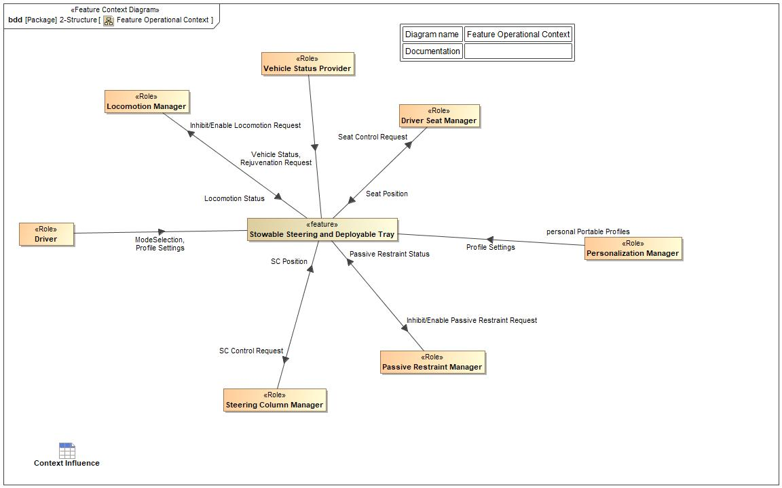

Figure 4: Feature Operational Context

## List of Influences

|  |  |  |
| --- | --- | --- |
| **ID** | **External Entity** | **Influence Description** |
| Inhibit/Enable Passive Restraint Request | Stowable Steering and Deployable Tray To Passive Restraint Manager | Command to Passive Restraint role to disable appropriate passive restraints associated with Stowable Steering Wheel. |
| Inhibit/Enable Locomotion Request | Stowable Steering and Deployable Tray To Locomotion Manager | Prevent the Vehicle from being driven. Vehicle should remain parked while Locomotion is inhibited. |
| Locomotion Status | Locomotion Manager To Stowable Steering and Deployable Tray | Provides the Locomotion Enable or Disable Status to feature. |
| ModeSelection | Driver To Stowable Steering and Deployable Tray | User Mode selection |
| Passive Restraint Status | Passive Restraint Manager To Stowable Steering and Deployable Tray | Current status of the Passive Restraints affecting Stowable Steering Wheel feature. |
| Profile Settings | Driver To Stowable Steering and Deployable Tray | The Driver's pre-defined set points for memory positions supported by Personal Profile feature. |
| Personalization Manager To Stowable Steering and Deployable Tray | The Driver's pre-defined set points for memory positions supported by Personal Profile feature. |
| Rejuvenation Request | Vehicle Status Provider To Stowable Steering and Deployable Tray | Request from the Rejuvenation Feature to support the Rejuvenation Mode. Will move Steering Column only. |
| SC Control Request | Stowable Steering and Deployable Tray To Steering Column Manager | Feature request to Arbitrate Steering Column according to selected mode |
| SC Position | Steering Column Manager To Stowable Steering and Deployable Tray | Position of the steering Column |
| Seat Control Request | Stowable Steering and Deployable Tray To Driver Seat Manager | Commands issued by Stowable Steering Wheel feature to Seat role to move user/driver seat. |
| Seat Position | Driver Seat Manager To Stowable Steering and Deployable Tray | Current Position and Status of user/driver seat. |
| Vehicle Status | Vehicle Status Provider To Stowable Steering and Deployable Tray | Vehicle Status used by feature to make decisions. Info like Vehicle Speed, PRNDL position, etc. |

Table 9: List of Influences

# Feature Modeling

## Operation Modes and States

**#Classification:** Optional (Mandatory for Functional Safety)

**#Link:** [RE Wiki – State Charts](http://wiki.ford.com/display/RequirementsEngineering/State+Charts?src=contextnavpagetreemode)

**#Hint:** State Charts are a popular means to express feature behavior in terms of states and modes. An advantage of this state machine like approach is that consistency can be easily verified.

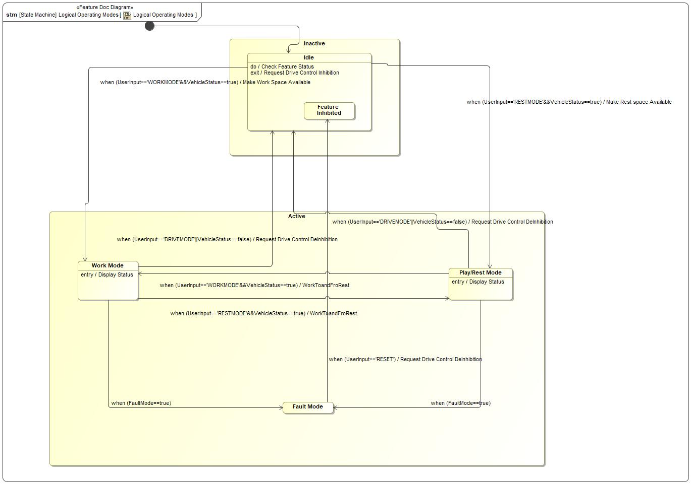

Figure 5: Logical Operating Modes

|  |  |  |
| --- | --- | --- |
| **State** | **Description** | **Requirements Reference** (optional) |
| Active | This is a Super-State for Work Mode, Play/Rest Mode and Fault Mode. This state runs when the feature is active. |  |
| Fault Mode | Upon any failure in Rest ,Play , Work Mode transitions or Actuations , they system shall be in Fault Mode |  |
| Feature Inhibited | This is a safe state for the situation that the vehicle is not in park and the feature activated without requests. The vehicle should slow down and go to idle state. |  |
| Idle | Do behavior: Check Feature Status  Exit behavior: Request Drive Control Inhibition |  |
| Inactive | This is a Super-State for the Idle Mode and Feature Inhibited Mode. This state runs when the feature is inactive. |  |
| Play/Rest Mode | State where user can be in Play /Rest mode , where he can move the seat position accordingly to gain comfort accordingly  Entry behavior: Display Status |  |
| Work Mode | State where user can be in Working mode with a work surface Available  Entry behavior: Display Status |  |

Table 10: Operation Modes and States on Logical Operating Modes

|  |  |  |
| --- | --- | --- |
| **Transition ID** | **Description** | **Requirements Reference**  (optional) |
| T1 | Name: Rest/Play to drive  Effect: Request Drive Control DeInhibition |  |
| T2 | Name: Play / rest to Fault state |  |
| T3 | Name: Rest / Play to Work  Effect: WorkToandFroRest |  |
| T4 | Name: Idle to Play / Rest  Effect: Make Rest space Available |  |
| T5 | Name: work to drive  Effect: Request Drive Control DeInhibition |  |
| T6 | Name: Work to Rest /Play  Effect: WorkToandFroRest |  |
| T7 | Name: Work to Fault state |  |
| T8 | Name: Fault to Feature Inhibited Mode  Effect: Request Drive Control DeInhibition |  |
| T9 | Name: Initialize |  |
| T10 | Name: Idle to Work  Effect: Make Work Space Available |  |

Table 11: Transitions between Operation Modes and States on Logical Operating Modes

## Use Cases

**#Classification:** Optional

**#Link:** [RE Wiki – Use Cases](http://wiki.ford.com/display/RequirementsEngineering/Use+Cases+Overview?src=contextnavpagetreemodehttp://wiki.ford.com/display/RequirementsEngineering/Use+Cases?src=contextnavpagetreemode)

### Use Case Diagram

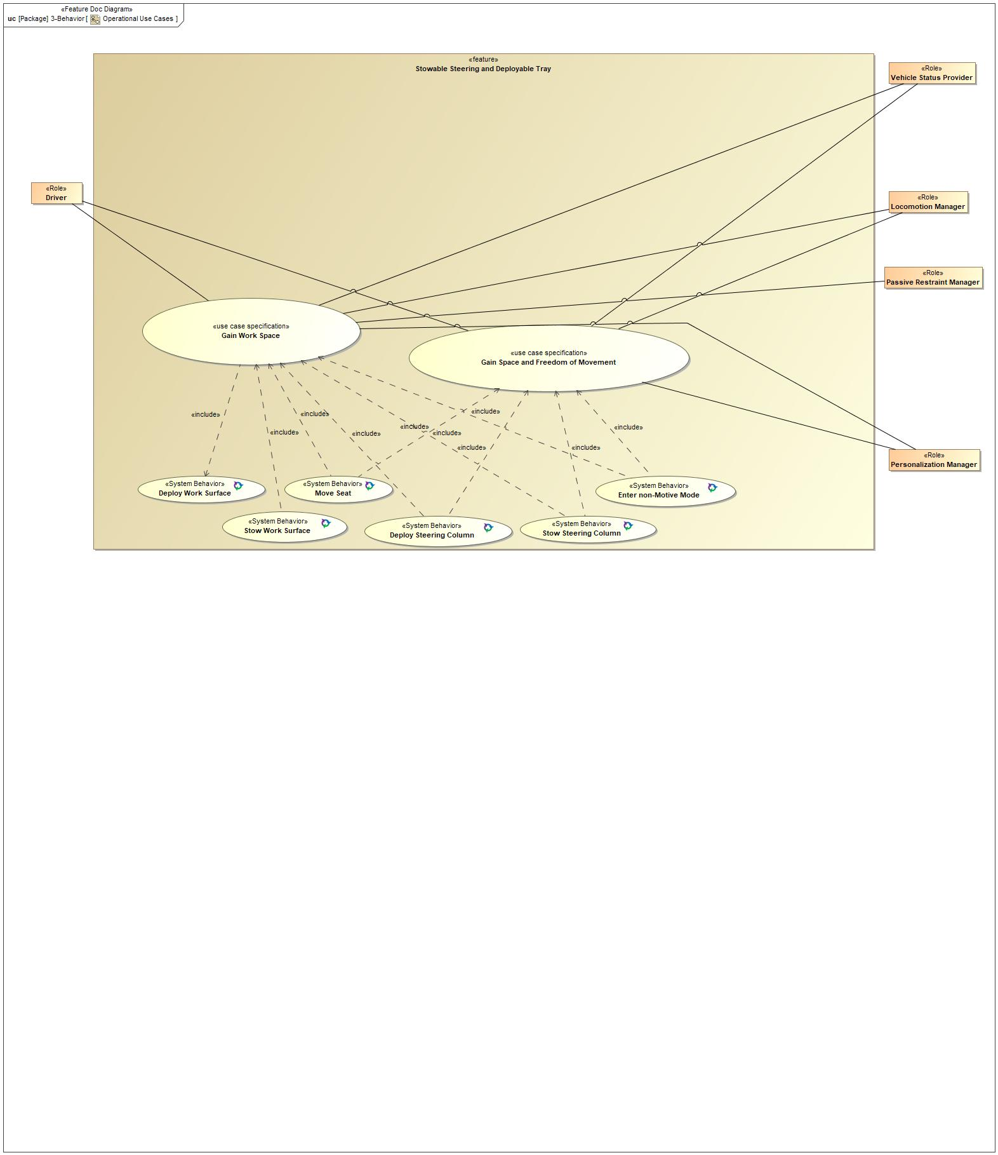

Figure 6: Operational Use Cases

### Actors

| **Actor** | **Description** |
| --- | --- |
| Driver | This is the Driver of the Vehicle using the Stowable Steering Wheel Feature. |
| Locomotion Manager | Inhibit Vehicle Locomotion when Stowable Steering Wheel Feature Deployed. |
| Passive Restraint Manager | The Driver Air Bag (DAB) is the main concern for the Passive Restraint. Other Passive Restraint features may need to be deactivated while Stowable Steering Wheel is active. |
| Personalization Manager | The Personal Portable Profiles Feature stores Memory Seat Positions used by the Stowable Steering Wheel Feature. |
| Vehicle Status Provider | Information needed from Vehicle to support operation of Stowable Steering Wheel Feature. |

Table 12: List of Actors

### Use Case Descriptions

**#Classification:** Optional

Deploy Steering Column

|  |  |  |
| --- | --- | --- |
| **Actors** |  | Driver |
|  | Locomotion Manager |
|  | Passive Restraint Manager |
|  | Personalization Manager |
|  | Vehicle Status Provider |
| **Subject** |  | Stowable Steering and Deployable Tray |
| **Description** |  | The Steering Column is returned to a drivable state only after the preconditions are met. |
| **Preconditions** | PreC1 | Passive Restraints Enabled |
| PreC2 | Vehicle Locomotion Enabled |
| PreC3 | Vehicle Parked |
| **Main Flow Description** |  | Steering Column moves to a drivable position in the allotted time. |

Deploy Work Surface

|  |  |  |
| --- | --- | --- |
| **Actors** |  | Driver |
|  | Locomotion Manager |
|  | Passive Restraint Manager |
|  | Personalization Manager |
|  | Vehicle Status Provider |
| **Subject** |  | Stowable Steering and Deployable Tray |
| **Description** |  | Deploy the Tray Table to serve as a working surface. |
| **Preconditions** | PreC1 | Passive Restraints Disabled |
| PreC2 | Vehicle Locomotion Disabled |
| PreC3 | Vehicle Parked |

Enter non-Motive Mode

|  |  |  |
| --- | --- | --- |
| **Actors** |  | Driver |
|  | Locomotion Manager |
|  | Passive Restraint Manager |
|  | Personalization Manager |
|  | Vehicle Status Provider |
| **Subject** |  | Stowable Steering and Deployable Tray |
| **Description** |  | non-Motive Mode prevents Vehicle Locomotion and is allowed when preconditions are met. |
| **Preconditions** | PreC1 | <undefined> |
| PreC2 | No Faults or Disallowed Conditions preventing disabling Passive Restraints |
| PreC3 | No Faults or Disallowed Conditions preventing non-Motive Mode |
| PreC4 | Vehicle Parked |
| **Main Flow Description** |  | Disable vehicle locomotion or vehicle cannot be driven. |

Gain Space and Freedom of Movement

|  |  |  |
| --- | --- | --- |
| **Actors** | Primary | Driver |
| Secondary | Locomotion Manager |
| Secondary | Vehicle Status Provider |
|  | Personalization Manager |
| **Subject** |  | Stowable Steering and Deployable Tray |
| **Description** |  |  |
| **Preconditions** | PreC1 | Appropriate Vehicle Status signals indicate the vehicle is parked and not moving. |
| **Triggers** | T1 | User initiates a request to utilize Rest Mode of the feature |
| **Main Flow Description** |  | Driver stows Steering Column, releaxes after gaining space and freedom of movement and deploys Steering Column once done and ready to drive vehicle. |
| **Main Flow** | M1 | Driver selects Mode Operation as Rest |
| M2 | SSW verifies vehicle status specifically vehicle in park and speed less than 5kph |
| M3 | If vehicle status and Vehicle configuration Valid, Feature requests to Inhibit Locmotion and Driver Airbgas Accordingly |
| M4 | After required Arbitration , SSW Feature requests Steering Column and Driver Seat system accordingly |
| M5 | If driver selects drive mode, feature moves column and seat accordingly |
| M6 | If seat and column are in drive position then loco hold and airbag hold released |
| **Alternative Flow Description** |  | Driver can cancel deployment or stowing operations at any time. |
| **Exceptional Flow Description** |  | Fail to Inhibit Passive Restraints or Vehicle Locomotion. |
| **Exceptional Flow Description** |  | Fail to deploy Steering Column or move Driver Seat to Driving Position. |
| **Exceptional Flow Steps** | E1 | If failure to deploy Steering Column or move Driver Seat to Driving Position then do not Enable Passive Restraint or Vehicle Locomotion. Inform Driver via HMI of condition and inform Driver what steps are available to return vehicle to a drivable state. |
| E2 | If failure to Inhibt Passive Restraints or Vehicle Locomotion then do not deploy SSW feature. Inform Driver via HMI what steps are available to correct failure if any. |
| **Postconditions** | PostC1 | Vehicle Steering Column, Driver Seat are in driving positions. |

Gain Work Space

|  |  |  |
| --- | --- | --- |
| **Actors** | Primary | Driver |
| Secondary | Locomotion Manager |
| Secondary | Passive Restraint Manager |
| Secondary | Vehicle Status Provider |
|  | Personalization Manager |
| **Subject** |  | Stowable Steering and Deployable Tray |
| **Description** |  |  |
| **Preconditions** | PreC1 | Appropriate Vehicle Status signals indicate the vehicle is parked and not moving. |
| **Triggers** | T1 | User initiates a request to utilize Work Mode of the feature |
| **Main Flow Description** |  | Driver deploys Work State Tray, uses Tray Table and stows Tray once done. |
| **Main Flow** | M1 | Driver selects Mode Operation as work |
| M2 | SSW verifies vehicle status specifically vehicle in park and speed less than 5kph |
| M3 | If vehicle status and Vehicle configuration Valid, Feature requests to Inhibit Locmotion and Driver Airbgas Accordingly |
| M4 | After required Arbitration , SSW Feature requests Steering Column and Driver Seat system accordingly |
| M5 | If driver selects drive mode, feature moves column and seat accordingly |
| M6 | If seat and column are in drive position then loco hold and airbag hold released |
| **Alternative Flow Description** |  | Driver can cancel deployment or stowing operations at any time. |
| **Exceptional Flow Description** |  | Fail to Inhibit Passive Restraints or Vehicle Locomotion. |
| **Exceptional Flow Description** |  | Fail to stow Tray Table or deploy Steering Column or move Driver Seat to Driving Position. |
| **Exceptional Flow Steps** | E1 | If failure to stow Tray Table or deploy Steering Column or move Driver Seat to Driving Position then do not Enable Passive Restraint or Vehicle Locomotion. Inform Driver via HMI of condition and inform Driver what steps are available to return vehicle to a drivable state. |
| E2 | If failure to Inhibt Passive Restraints or Vehicle Locomotion then do not deploy SSW feature. Inform Driver via HMI what steps are available to correct failure if any. |
| **Postconditions** | PostC1 | Vehicle Steering Column, Driver Seat are in driving positions. |

Move Seat

|  |  |  |
| --- | --- | --- |
| **Actors** |  | Driver |
|  | Locomotion Manager |
|  | Passive Restraint Manager |
|  | Personalization Manager |
|  | Vehicle Status Provider |
| **Subject** |  | Stowable Steering and Deployable Tray |
| **Description** |  | The Driver Seat is moved to support the different Use Cases of the Feature. |
| **Preconditions** | PreC1 | Passive Restraints Disabled |
| PreC2 | Vehicle Locomotion Disabled |
| PreC3 | Vehicle Parked |
| **Main Flow Description** |  | Seat moves to assigned position in the allotted time. |

Stow Steering Column

|  |  |  |
| --- | --- | --- |
| **Actors** |  | Driver |
|  | Locomotion Manager |
|  | Passive Restraint Manager |
|  | Personalization Manager |
|  | Vehicle Status Provider |
| **Subject** |  | Stowable Steering and Deployable Tray |
| **Description** |  | The Steering Column will only stow when the pre-conditions are met. |
| **Preconditions** | PreC1 | Passive Restraints Disabled |
| PreC2 | Vehicle Locomotion Disabled |
| PreC3 | Vehicle Parked |
| **Main Flow Description** |  | Stow Steering Column to support feature use in the allotted time. |

Stow Work Surface

|  |  |  |
| --- | --- | --- |
| **Actors** |  | Driver |
|  | Locomotion Manager |
|  | Passive Restraint Manager |
|  | Personalization Manager |
|  | Vehicle Status Provider |
| **Subject** |  | Stowable Steering and Deployable Tray |
| **Description** |  | Stow Work Surface stows the Tray Table when the user is finished using it. |
| **Preconditions** | PreC1 | Tray Table Deployed |

## Driving and Operation Scenarios

**#Classification:** Optional (Mandatory for Functional Safety)

**#Functional Safety:** Driving and operating scenarios which impact the functionality of the feature can be used to check, if the situation analysis in the HARA is complete

**#Link:** [RE Wiki – Driving Scenarios](http://wiki.ford.com/display/RequirementsEngineering/Driving+Scenarios?src=contextnavpagetreemode)

## Decision Tables

**#Classification:** Optional

**#Link:** [RE Wiki – Decision Tables](http://wiki.ford.com/display/RequirementsEngineering/Decision+Table).

**#Hint:** Use decision table, if behavior is not state based (in that case prefer state chart from ch. 5.1) and based purely on current inputs.

*Not supported by MagicDraw report generation.*

# Feature Requirements

**#Functional Safety:** In general, safety requirements are not listed here. However, it is possible that later in the development process, a non-safety requirement becomes a safety requirement. In such a case it may remain on this list.

**#Link:** [RE Wiki – How to write good requirements](http://wiki.ford.com/display/RequirementsEngineering/How+to+write+better+requirements?src=contextnavpagetreemode).

## Functional Requirements

FR01 Simultaneous Actuation

The three degrees of motion (steering wheel rotation, column telescoping and rake angle) can all be performed simultaneously if desired.

|  |  |  |  |  |  |  |  |
| --- | --- | --- | --- | --- | --- | --- | --- |
| Requirement ID: FR01 | | | | | | | |
| **Rationale** | Define basic user operation. | | | | | | |
| **Acceptance Criteria** | Observed behavior consistent with required operation. | | | | | | |
| **Notes** |  | | | | | | |
| **Source** |  | | | | | **Owner** | Feature/Doc Owner |
| **Source Req.** |  | | | | | **V&V Method** |  |
| **Type** |  | | | **Priority** |  | **Status** |  |
| [Req. Template](http://wiki.ford.com/display/RequirementsEngineering/Requirements+Attributes) Version | | 6.0 | End of Requirement | | | | |

FR02 Feature Operating Modes

The Feature shall support the following operating modes: 'Disabled', 'Inactive', 'Work', 'Rest' and 'Fault'.

|  |  |  |  |  |  |  |  |
| --- | --- | --- | --- | --- | --- | --- | --- |
| Requirement ID: FR02 | | | | | | | |
| **Rationale** | Define basic operating modes available to user. | | | | | | |
| **Acceptance Criteria** | Observed behavior consistent with required operation. | | | | | | |
| **Notes** |  | | | | | | |
| **Source** |  | | | | | **Owner** | Feature/Doc Owner |
| **Source Req.** |  | | | | | **V&V Method** |  |
| **Type** |  | | | **Priority** |  | **Status** |  |
| [Req. Template](http://wiki.ford.com/display/RequirementsEngineering/Requirements+Attributes) Version | | 6.0 | End of Requirement | | | | |

FR03 Feature Availability

The Feature shall be available if all the conditions are met: 1) Ignition Accessory state or Ignition Run state, 2) vehicle in 'Park', 3) power level is not in battery saver mode

|  |  |  |  |  |  |  |  |
| --- | --- | --- | --- | --- | --- | --- | --- |
| Requirement ID: FR03 | | | | | | | |
| **Rationale** | Vehicle should not be driveable and have power available to run the feature. | | | | | | |
| **Acceptance Criteria** | Observed behavior consistent with required operation. Feature functions available only if all conditions met. | | | | | | |
| **Notes** |  | | | | | | |
| **Source** |  | | | | | **Owner** | Feature/Doc Owner |
| **Source Req.** |  | | | | | **V&V Method** |  |
| **Type** |  | | | **Priority** |  | **Status** |  |
| [Req. Template](http://wiki.ford.com/display/RequirementsEngineering/Requirements+Attributes) Version | | 6.0 | End of Requirement | | | | |

FR05 Stow Steering Column

The Feature shall request to stow the Steering Column into a stowed position upon driver command.

|  |  |  |  |  |  |  |  |
| --- | --- | --- | --- | --- | --- | --- | --- |
| Requirement ID: FR05 | | | | | | | |
| **Rationale** | Define basic user operation. | | | | | | |
| **Acceptance Criteria** | Observed behavior consistent with required operation. | | | | | | |
| **Notes** |  | | | | | | |
| **Source** |  | | | | | **Owner** | Feature/Doc Owner |
| **Source Req.** |  | | | | | **V&V Method** |  |
| **Type** |  | | | **Priority** |  | **Status** |  |
| [Req. Template](http://wiki.ford.com/display/RequirementsEngineering/Requirements+Attributes) Version | | 6.0 | End of Requirement | | | | |

FR06 Deploy Steering Column

The Feature shall request to deploy the Steering Column to a drivable state upon driver command.

|  |  |  |  |  |  |  |  |
| --- | --- | --- | --- | --- | --- | --- | --- |
| Requirement ID: FR06 | | | | | | | |
| **Rationale** | Define basic user operation. | | | | | | |
| **Acceptance Criteria** | Observed behavior consistent with required operation. | | | | | | |
| **Notes** |  | | | | | | |
| **Source** |  | | | | | **Owner** | Feature/Doc Owner |
| **Source Req.** |  | | | | | **V&V Method** |  |
| **Type** |  | | | **Priority** |  | **Status** |  |
| [Req. Template](http://wiki.ford.com/display/RequirementsEngineering/Requirements+Attributes) Version | | 6.0 | End of Requirement | | | | |

FR07 Deploy Work Surface

The Feature shall provide a deployable work surface area to the driver upon driver command.

|  |  |  |  |  |  |  |  |
| --- | --- | --- | --- | --- | --- | --- | --- |
| Requirement ID: FR07 | | | | | | | |
| **Rationale** | Define basic user operation. | | | | | | |
| **Acceptance Criteria** | Observed behavior consistent with required operation. | | | | | | |
| **Notes** |  | | | | | | |
| **Source** |  | | | | | **Owner** | Feature/Doc Owner |
| **Source Req.** |  | | | | | **V&V Method** |  |
| **Type** |  | | | **Priority** |  | **Status** |  |
| [Req. Template](http://wiki.ford.com/display/RequirementsEngineering/Requirements+Attributes) Version | | 6.0 | End of Requirement | | | | |

FR08 Stow Work Surface

The Feature shall stow the Work Surface to a drivable state upon driver command.

|  |  |  |  |  |  |  |  |
| --- | --- | --- | --- | --- | --- | --- | --- |
| Requirement ID: FR08 | | | | | | | |
| **Rationale** | Define basic user operation. | | | | | | |
| **Acceptance Criteria** | Observed behavior consistent with required operation. | | | | | | |
| **Notes** |  | | | | | | |
| **Source** |  | | | | | **Owner** | Feature/Doc Owner |
| **Source Req.** |  | | | | | **V&V Method** |  |
| **Type** |  | | | **Priority** |  | **Status** |  |
| [Req. Template](http://wiki.ford.com/display/RequirementsEngineering/Requirements+Attributes) Version | | 6.0 | End of Requirement | | | | |

FR09 Automatic Work Surface

The Feature shall deploy the Tray Table to/from fully deployed from/to fully stowed with no intermediate positions.

|  |  |  |  |  |  |  |  |
| --- | --- | --- | --- | --- | --- | --- | --- |
| Requirement ID: FR09 | | | | | | | |
| **Rationale** | Define basic user operation. | | | | | | |
| **Acceptance Criteria** | Observed normal movement profile unless movement is interupted by user or detected fault. | | | | | | |
| **Notes** |  | | | | | | |
| **Source** |  | | | | | **Owner** | Feature/Doc Owner |
| **Source Req.** |  | | | | | **V&V Method** |  |
| **Type** |  | | | **Priority** |  | **Status** |  |
| [Req. Template](http://wiki.ford.com/display/RequirementsEngineering/Requirements+Attributes) Version | | 6.0 | End of Requirement | | | | |

FR12 Inhibit Locomotion

The Feature shall request the vehicle to inhibit locomotion while in a Rest, Play or Work states or during transition to/ from each of the states.

|  |  |  |  |  |  |  |  |
| --- | --- | --- | --- | --- | --- | --- | --- |
| Requirement ID: FR12 | | | | | | | |
| **Rationale** | Define basic user operation. | | | | | | |
| **Acceptance Criteria** | Observed behavior consistent with required operation. | | | | | | |
| **Notes** |  | | | | | | |
| **Source** |  | | | | | **Owner** | Feature/Doc Owner |
| **Source Req.** |  | | | | | **V&V Method** |  |
| **Type** |  | | | **Priority** |  | **Status** |  |
| [Req. Template](http://wiki.ford.com/display/RequirementsEngineering/Requirements+Attributes) Version | | 6.0 | End of Requirement | | | | |

FR13 Return to Drivable State

To return vehicle to a drivable state, the Feature shall: 1) stow the tray table, 2) Request to deploy steering column, 3) Request to return seat to memory position, 4) request activation of Passive Restraints, 5) request activation of vehicle locomotion

|  |  |  |  |  |  |  |  |
| --- | --- | --- | --- | --- | --- | --- | --- |
| Requirement ID: FR13 | | | | | | | |
| **Rationale** | Define basic user operation. | | | | | | |
| **Acceptance Criteria** | Observed behavior consistent with required operation. | | | | | | |
| **Notes** |  | | | | | | |
| **Source** |  | | | | | **Owner** | Feature/Doc Owner |
| **Source Req.** | * -1651816397.jpg FR02 Feature Operating Modes | | | | | **V&V Method** |  |
| **Type** |  | | | **Priority** |  | **Status** |  |
| [Req. Template](http://wiki.ford.com/display/RequirementsEngineering/Requirements+Attributes) Version | | 6.0 | End of Requirement | | | | |

FR15 Adjust Seat Position

The Feature shall allow the driver shall to adjust posture and position of driver seat consistent with supported operating states.

|  |  |  |  |  |  |  |  |
| --- | --- | --- | --- | --- | --- | --- | --- |
| Requirement ID: FR15 | | | | | | | |
| **Rationale** | Define basic user operation. | | | | | | |
| **Acceptance Criteria** | Noramal seat movement controls work while feature is deployed. | | | | | | |
| **Notes** |  | | | | | | |
| **Source** |  | | | | | **Owner** | Feature/Doc Owner |
| **Source Req.** |  | | | | | **V&V Method** |  |
| **Type** |  | | | **Priority** |  | **Status** |  |
| [Req. Template](http://wiki.ford.com/display/RequirementsEngineering/Requirements+Attributes) Version | | 6.0 | End of Requirement | | | | |

FR16 Seat Position Preset Memory

The feature shall have 1 preset memory position for each of the operating states. The operating states are as follows: Rest/ Play and Work.

|  |  |  |  |  |  |  |  |
| --- | --- | --- | --- | --- | --- | --- | --- |
| Requirement ID: FR16 | | | | | | | |
| **Rationale** | Define basic user operation. | | | | | | |
| **Acceptance Criteria** | Observed behavior consistent with required operation. | | | | | | |
| **Notes** |  | | | | | | |
| **Source** |  | | | | | **Owner** | Feature/Doc Owner |
| **Source Req.** |  | | | | | **V&V Method** |  |
| **Type** |  | | | **Priority** |  | **Status** |  |
| [Req. Template](http://wiki.ford.com/display/RequirementsEngineering/Requirements+Attributes) Version | | 6.0 | End of Requirement | | | | |

FR18 Halt Transitional Movements

The Feature shall allow the driver to instantly stop/start the movement of any motorized components associated with the feature for any reason during transitions between different supported operating states.

|  |  |  |  |  |  |  |  |
| --- | --- | --- | --- | --- | --- | --- | --- |
| Requirement ID: FR18 | | | | | | | |
| **Rationale** | Define basic user operation. | | | | | | |
| **Acceptance Criteria** | Observed behavior consistent with required operation. | | | | | | |
| **Notes** |  | | | | | | |
| **Source** |  | | | | | **Owner** | Feature/Doc Owner |
| **Source Req.** |  | | | | | **V&V Method** |  |
| **Type** |  | | | **Priority** |  | **Status** |  |
| [Req. Template](http://wiki.ford.com/display/RequirementsEngineering/Requirements+Attributes) Version | | 6.0 | End of Requirement | | | | |

FR19 Rejuvenation Feature

The Feature shall request stow the steering column upon request from the Rejuvenation Feature.

|  |  |  |  |  |  |  |  |
| --- | --- | --- | --- | --- | --- | --- | --- |
| Requirement ID: FR19 | | | | | | | |
| **Rationale** | Define basic user operation and scope of operation for Rejuvenation Feature support. | | | | | | |
| **Acceptance Criteria** | Observed behavior consistent with required operation. | | | | | | |
| **Notes** |  | | | | | | |
| **Source** |  | | | | | **Owner** | Feature/Doc Owner |
| **Source Req.** |  | | | | | **V&V Method** |  |
| **Type** |  | | | **Priority** |  | **Status** |  |
| [Req. Template](http://wiki.ford.com/display/RequirementsEngineering/Requirements+Attributes) Version | | 6.0 | End of Requirement | | | | |

FR20 Portable Profiles Feature

The Feature shall communicate the preset memory positions to the Portable Profiles Feature.

|  |  |  |  |  |  |  |  |
| --- | --- | --- | --- | --- | --- | --- | --- |
| Requirement ID: FR20 | | | | | | | |
| **Rationale** | Define basic user operation and scope of operation for Portable Profiles Feature. | | | | | | |
| **Acceptance Criteria** | Observed behavior consistent with required operation. | | | | | | |
| **Notes** |  | | | | | | |
| **Source** |  | | | | | **Owner** | Feature/Doc Owner |
| **Source Req.** |  | | | | | **V&V Method** |  |
| **Type** |  | | | **Priority** |  | **Status** |  |
| [Req. Template](http://wiki.ford.com/display/RequirementsEngineering/Requirements+Attributes) Version | | 6.0 | End of Requirement | | | | |

FR21 Drivability of Rake Angles

The feature shall not inhibit the steering ability of the vehicle at any of the rake angles for the steering column

|  |  |  |  |  |  |  |  |
| --- | --- | --- | --- | --- | --- | --- | --- |
| Requirement ID: FR21 | | | | | | | |
| **Rationale** | Define the limited range of Rake | | | | | | |
| **Acceptance Criteria** |  | | | | | | |
| **Notes** |  | | | | | | |
| **Source** |  | | | | | **Owner** |  |
| **Source Req.** |  | | | | | **V&V Method** |  |
| **Type** |  | | | **Priority** |  | **Status** |  |
| [Req. Template](http://wiki.ford.com/display/RequirementsEngineering/Requirements+Attributes) Version | | 6.0 | End of Requirement | | | | |

FR22 Simultaneous Action

The feature shall control the three degrees of motion (steering wheel rotation, column telescoping and rake angle) simultaneously if desired

|  |  |  |  |  |  |  |  |
| --- | --- | --- | --- | --- | --- | --- | --- |
| Requirement ID: FR22 | | | | | | | |
| **Rationale** | Define various movements of Sterring Column | | | | | | |
| **Acceptance Criteria** |  | | | | | | |
| **Notes** |  | | | | | | |
| **Source** |  | | | | | **Owner** |  |
| **Source Req.** |  | | | | | **V&V Method** |  |
| **Type** |  | | | **Priority** |  | **Status** |  |
| [Req. Template](http://wiki.ford.com/display/RequirementsEngineering/Requirements+Attributes) Version | | 6.0 | End of Requirement | | | | |

FR23 Drivability of Telescope Positions

The feature shall no inhibit the generally controllable (C0) nature of the steering column in any of the telescoping positions.

|  |  |  |  |  |  |  |  |
| --- | --- | --- | --- | --- | --- | --- | --- |
| Requirement ID: FR23 | | | | | | | |
| **Rationale** | Define the Constraint of steering column Tele movement | | | | | | |
| **Acceptance Criteria** |  | | | | | | |
| **Notes** |  | | | | | | |
| **Source** |  | | | | | **Owner** |  |
| **Source Req.** |  | | | | | **V&V Method** |  |
| **Type** |  | | | **Priority** |  | **Status** |  |
| [Req. Template](http://wiki.ford.com/display/RequirementsEngineering/Requirements+Attributes) Version | | 6.0 | End of Requirement | | | | |

### Error Handling

FR04 Inform User of Status

The Feature shall inform the User of Deployment or Stowing Status which shall include success or failure results and may include reasons for failure.

|  |  |  |  |  |  |  |  |
| --- | --- | --- | --- | --- | --- | --- | --- |
| Requirement ID: FR04 | | | | | | | |
| **Rationale** | Define basic user HMI requirements. | | | | | | |
| **Acceptance Criteria** | Observed behavior consistent with required operation. | | | | | | |
| **Notes** |  | | | | | | |
| **Source** |  | | | | | **Owner** | Feature/Doc Owner |
| **Source Req.** |  | | | | | **V&V Method** |  |
| **Type** |  | | | **Priority** |  | **Status** |  |
| [Req. Template](http://wiki.ford.com/display/RequirementsEngineering/Requirements+Attributes) Version | | 6.0 | End of Requirement | | | | |

## Non-Functional Requirements

***#Hint:*** *Non-functional requirements specify some performance criteria in addition to the functional behavior given defined by the functional requirements. Timing (if not already included in the functional requirements), security details (e.g. how secure does an algorithm have to be) reliability (e.g. mean time between failure) or maintainability could be specified in this section.*

### Safety

**#Hint:** Only those safety requirements, which are not related to Functional Safety (ISO26262) should go here. For Functional Safety refer to chapter 7 “Functional Safety”.

*Not supported by MagicDraw report generation.*

### Security

No Security Requirements specified.

### Reliability

FR17 Number of Deployment Cycles

The number of complete deployment cycles without mechanical or electrical failure shall equal or exceed TBD.

|  |  |  |  |  |  |  |  |
| --- | --- | --- | --- | --- | --- | --- | --- |
| Requirement ID: FR17 | | | | | | | |
| **Rationale** | Define basic reliability requirement. | | | | | | |
| **Acceptance Criteria** | No electrical or mechanical failures during specified test run. | | | | | | |
| **Notes** |  | | | | | | |
| **Source** |  | | | | | **Owner** | Feature/Doc Owner |
| **Source Req.** |  | | | | | **V&V Method** |  |
| **Type** |  | | | **Priority** |  | **Status** |  |
| [Req. Template](http://wiki.ford.com/display/RequirementsEngineering/Requirements+Attributes) Version | | 6.0 | End of Requirement | | | | |

## HMI Requirements

**#Hint:** Requirements in this section could specify details of e.g. the icons, the GUI or the sounds.

No HMI Requirements specified.

## Other Requirements

### Design Requirements

***#Hint:*** *Requirements of a Logical Function should be typically agnostic of their SW/HW implementation*. If for specific reasons the function owner needs to define explicitly design constraints on the solution, it can be done in this chapter.

*Not supported by MagicDraw report generation.*

### Manufacturing Requirements

No Manufacturing Requirements specified.

### Service Requirements

**#Hint:** Requirements in this section could specify, e.g. what needs to be considered, if individual ECUs are replaced or new SW is flashed to ECUs (parameter set in non-volatile memory might get inconsistent and needs also to be updated).

No Service Requirements specified.

### After Sales Requirements

**#Hint:** Requirements in this section could specify, e.g. input for the Owner’s Manual could be gathered.

No After Sales Requirements specified.

### Process Requirements

**#Hint**: Requirements in this section are relevant for the development process of the feature, e.g. ISO26262 compliance.

No Process Requirements specified.

### Uncategorized Requirements

***#Hint:*** *Requirements* in this section are in scope of this Feature Document but do not fit in any of the previous categories.

FR10 "Work State" Deploy Time

"Work State" shall complete deployment from "Drive State" within 15 seconds of user pressing "Work State" button.

|  |  |  |  |  |  |  |  |
| --- | --- | --- | --- | --- | --- | --- | --- |
| Requirement ID: FR10 | | | | | | | |
| **Rationale** | Define basic performance requirement. | | | | | | |
| **Acceptance Criteria** | Movement within specified time limit | | | | | | |
| **Notes** |  | | | | | | |
| **Source** |  | | | | | **Owner** | Feature/Doc Owner |
| **Source Req.** |  | | | | | **V&V Method** |  |
| **Type** |  | | | **Priority** |  | **Status** |  |
| [Req. Template](http://wiki.ford.com/display/RequirementsEngineering/Requirements+Attributes) Version | | 6.0 | End of Requirement | | | | |

FR11 Ease of Feature State Movement Time

The maximum transition time from one supported State to another shall be 5 seconds. States are as follows: Rest/ Play and Work.

|  |  |  |  |  |  |  |  |
| --- | --- | --- | --- | --- | --- | --- | --- |
| Requirement ID: FR11 | | | | | | | |
| **Rationale** | Define scope of a performance requirement. | | | | | | |
| **Acceptance Criteria** | Observed behavior consistent with required operation. | | | | | | |
| **Notes** |  | | | | | | |
| **Source** |  | | | | | **Owner** | Feature/Doc Owner |
| **Source Req.** |  | | | | | **V&V Method** |  |
| **Type** |  | | | **Priority** |  | **Status** |  |
| [Req. Template](http://wiki.ford.com/display/RequirementsEngineering/Requirements+Attributes) Version | | 6.0 | End of Requirement | | | | |

FR14 Return to Drivable State Time

For deployed Steering Wheel Column, Stow Tray Table and Driver Seat return to a Drivable State shall take no more than 15 seconds.

|  |  |  |  |  |  |  |  |
| --- | --- | --- | --- | --- | --- | --- | --- |
| Requirement ID: FR14 | | | | | | | |
| **Rationale** | Define basic performance requirement. | | | | | | |
| **Acceptance Criteria** | Time limit met for completion of required steps | | | | | | |
| **Notes** |  | | | | | | |
| **Source** |  | | | | | **Owner** | Feature/Doc Owner |
| **Source Req.** |  | | | | | **V&V Method** |  |
| **Type** |  | | | **Priority** |  | **Status** |  |
| [Req. Template](http://wiki.ford.com/display/RequirementsEngineering/Requirements+Attributes) Version | | 6.0 | End of Requirement | | | | |

# Functional Safety

**#Classification**: Functional Safety only

**#Hint:** This section is dedicated to the Ford Functional Safety (ISO26262) process. For details of this process refer **#Link:** [Ford Functional Safety Sharepoint](https://pd3.spt.ford.com/sites/GlobalFunctionalSafety/Pages/default.aspx)

**#Contact:** [*RE Wiki Roles & Responsibilites page – Role: Application Functional Safety Engineer*](http://wiki.ford.com/display/RequirementsEngineering/Default+Contacts+for+Stakeholder+Roles#ApplicationFunctionalSafetyEngineer)

## System Behaviors for HARA

**#Classification**: Functional Safety only

**#Hint:** List of selected system behaviors is an input to the Hazard Analysis and Risk Assessment (HARA). There needs to be a rationale why other system behaviors / functions are not considered.

|  |  |
| --- | --- |
| **ID** | **Name** |
|  | Enter non-Motive Mode  non-Motive Mode prevents Vehicle Locomotion and is allowed when preconditions are met. |
|  | Stow Work Surface  Stow Work Surface stows the Tray Table when the user is finished using it. |
|  | Move Seat  The Driver Seat is moved to support the different Use Cases of the Feature. |
|  | Stow Steering Column  The Steering Column will only stow when the pre-conditions are met. |
|  | Deploy Steering Column  The Steering Column is returned to a drivable state only after the preconditions are met. |
|  | Deploy Work Surface  Deploy the Tray Table to serve as a working surface. |
|  | Disable Driver Airbag |

Table 13: System Behaviors for HARA

## Safety Assumptions

**#Hint:** Copy the assumptions from the document "FFSD 02 Hazard Analysis and Risk Assessment”, Tab. “2 - Assumptions” with “Ref/ID”, “Name”, “Category”, “Description”, “Purpose”. In this document, additionally a reference to the requirement ID is inserted.

**#Link:** [Functional Safety Sharepoint](https://pd3.spt.ford.com/sites/GlobalFunctionalSafety/Pages/default.aspx) – HARA

|  |  |  |
| --- | --- | --- |
| ID | Assumption | |
|  | **Name** | Full steerability in stow, un-stow and transitioning |
| **Description** | Full steerability is available to the driver in all positions (un-stowed, while transitioning, stowed). Driver may not be able to reach the steering wheel. Ergonomic review of out of reach assessment is needed to reduce the ratings |
| **Purpose** | Clarification for controllability ratings during transition. |
| **Category** | Controllability |
| **Related Requirement IDs** |  |
| **ASMP05** | **Name** | Externally Commanded Stow/Un-Stow |
| **Description** | An external ECU commands the stowable column module to Stow/Un-Stow. |
| **Purpose** | It is assumed that the request to Stow/Un-Stow represnents the driver intention. |
| **Category** | Behavioral |
| **Related Requirement IDs** |  |
| **ASMP08** | **Name** | Definition of Vehicle Speed Ranges |
| **Description** | Parking Speeds: <12mph (20kph)  City Speeds: 12-36mph (20-58kph)  Hwy Speeds: >36mph (58kph) |
| **Purpose** | Definition of vehicle speed ranges described in HARA. Aligns with "Guidance for ISO 26262 HARA Assessments of Severity, Exposure and Controllability" (Revised 2018/01/17) |
| **Category** | Controllability |
| **Related Requirement IDs** |  |

Table 14: Functional Safety Assumptions

## Safety Goals

**#Classification**: Functional Safety only

**#Hint:** The list of Functional Safety Goals is an output of the Hazard Analysis and Risk Assessment (HARA) and therefore not required during the initial creation of the Feature Document.

**#Link:** [Functional Safety Sharepoint](https://pd3.spt.ford.com/sites/GlobalFunctionalSafety/Pages/default.aspx) – HARA

|  |  |  |  |  |
| --- | --- | --- | --- | --- |
| ID | Goal | | | |
| **SG01** | **Goal Name** | Prevent stowed steering wheel while the vehicle is in motion | | |
| **Description** | SSC shall prevent the steering wheel from being stowed when the vehicle is moving at speed | | |
| **Safety Goal Concept** | Safety Goal Concept: | | |
| **ASIL** | B | **FTTI** |  |
| **Related FSR IDs** | * FSR00 * SG01.FSR01 * SG01.FSR02 * SG01.FSR03 * SG01FSR04 * SG01FSR05 | | |
| **SG02** | **Goal Name** | Prevent unintended seat movement while the vehicle is in motion | | |
| **Description** | The system shall prevent unintentional enter to rest mode | | |
| **Safety Goal Concept** | Safety Goal Concept: | | |
| **ASIL** | B | **FTTI** |  |
| **Related FSR IDs** | * FSR00 * SG01.FSR01 * SG01.FSR02 * SG02.FSR01 * SG02.FSR02 | | |

Table 15: Functional Safety Goals

## Functional Safety Requirements

**#Classification**: Functional Safety only

**#Hint:** The section lists the Functional Safety Requirements (FSRs) derived from

* a Safety Goal (list in subsections **Error! Reference source not found.** and following)

in this case each FSR should trace back to a safety goal in ch. 6.3

* and Assumptions (list in subsection **Error! Reference source not found.**).

in this case each FSR should trace back to an assumption in ch. 6.2.

In section **Error! Reference source not found.** “**Error! Reference source not found.**” the initial FSRs from chapters **Error! Reference source not found.** to **Error! Reference source not found.** may be decomposed, if required.

**#Link:** [Functional Safety Sharepoint](https://pd3.spt.ford.com/sites/GlobalFunctionalSafety/Pages/default.aspx) – Functional Safety Concept

[RE Wiki - Requirements Attributes](http://wiki.ford.com/display/RequirementsEngineering/Requirements+Attributes)

**#Classification**: Functional Safety only

**#Hint:** The section lists the Functional Safety Requirements (FSRs) derived from a Safety Goal and Assumptions.

The following should be noted for the use of the attribute fields for FSRs

- The “Source Req” trace link field in each FSR should have a reference to

- a safety goal in ch. 6.3 “Safety Goals” or

- an assumption in ch. 6.2 “Safety Assumptions”

**#Link:** [Functional Safety Sharepoint](https://pd3.spt.ford.com/sites/GlobalFunctionalSafety/Pages/default.aspx) – Functional Safety Concept

[RE Wiki - Requirements Attributes](http://wiki.ford.com/display/RequirementsEngineering/Requirements+Attributes)

### Safety Goal: SG01 Prevent stowed steering wheel while the vehicle is in motion

**Name:** Prevent stowed steering wheel while the vehicle is in motion

**Purpose:** Prevent steering wheel to go out of reach of the driver

**Text:** SSC shall prevent the steering wheel from being stowed when the vehicle is moving at speed

**ASIL:** B

#### Safety Goal Concept

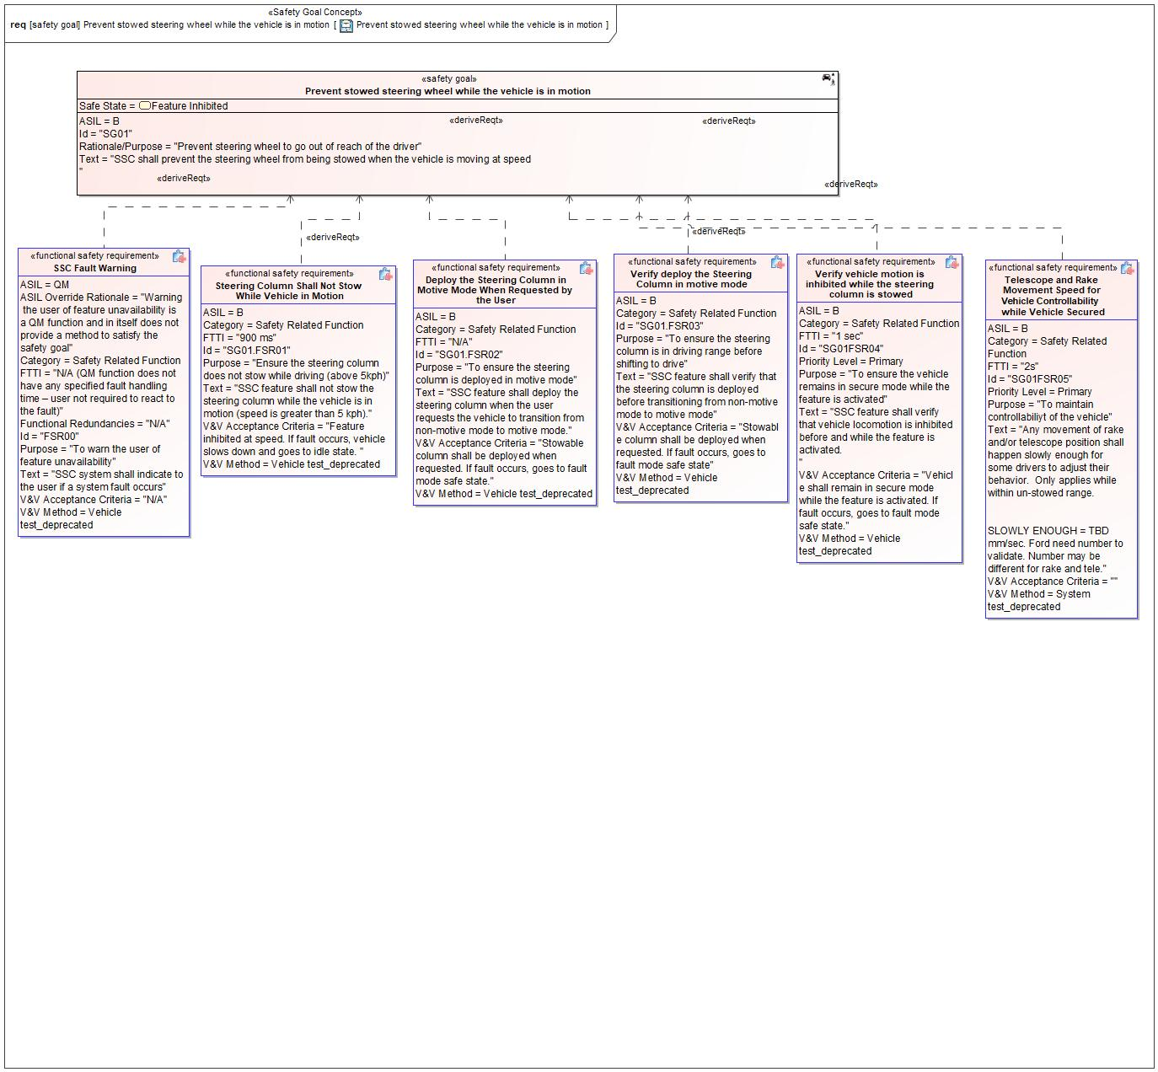

Figure 1: Prevent stowed steering wheel while the vehicle is in motion – Prevent stowed steering wheel while the vehicle is in motion

*Note: The authoritative source for the Safety Goals is document “FFSD 02 Hazard Analysis* *and Risk Assessment”. The documentation of Safety Goals in this chapter (In the Argumentation for Safety Goal achievement) is for information purposes only.*

*The authoritative source for the Functional Safety Requirements is section 2.1.x.3: of this document. The documentation of Functional Safety Requirements in the following chapter (complete or summarised) is for information purposes only.*

#### Warning and Recovery Concept

No Warning and Recovery Concept diagram specified.

#### Functional Safety Requirements without Dedicated Diagram

**#Hint:** The following Functional Safety Requirements are not depicted on dedicated requirements diagrams and are therefore all listed here.

FSR00 SSC Fault Warning

SSC system shall indicate to the user if a system fault occurs

Satisfied by:

* Logicals:
  + HMI Actuator
  + HMI Controller
  + HMI Sensor
  + HMI System
  + Stowable Feature Controller
  + Stowable Steering and Deployable Tray Feature

Related to:

* Safe States:
  + Fault Mode
  + Feature Inhibited
* Operating Modes:
  + Fault Mode

|  |  |  |  |  |  |  |  |
| --- | --- | --- | --- | --- | --- | --- | --- |
| Requirement ID: FSR00 | | | | | | | |
| **Purpose** | To warn the user of feature unavailability | | | | | | |
| **V&V Acceptance Criteria** | N/A | | | | | | |
| **Notes** |  | | | | | | |
| **Source** |  | | | | | **Owner** |  |
| **Source Req.** | * -176875836.jpg SG01 Prevent stowed steering wheel while the vehicle is in motion * -176875836.jpg SG02 Prevent unintended seat movement while the vehicle is in motion | | | | | **V&V Method** | Vehicle test_deprecated |
| **Type** | N/A | | **Priority** | | N/A | **Status** |  |
| **ASIL** | ASIL Override Rationale - Warning the user of feature unavailability is a QM function and in itself does not provide a method to satisfy the safety goal  QM | | **Category** | | Safety Related Function | **Fault Handling Time** | N/A |
| [Req. Template](http://wiki.ford.com/display/RequirementsEngineering/Requirements+Attributes) Version | | 6.0 | | End of Requirement | | | |

SG01.FSR01 Steering Column Shall Not Stow While Vehicle in Motion

SSC feature shall not stow the steering column while the vehicle is in motion (speed is greater than 5 kph).

Satisfied by:

* Logicals:
  + Steering Column Controller
  + Steering Column Tele Sensor
  + Stowable Feature Controller
  + Stowable Steering and Deployable Tray Feature
  + Stowable Steering Tele Actuator

Related to:

* Safe States:
  + Feature Inhibited
* Operating Modes:
  + Play/Rest Mode
  + Work Mode

|  |  |  |  |  |  |  |  |
| --- | --- | --- | --- | --- | --- | --- | --- |
| Requirement ID: SG01.FSR01 | | | | | | | |
| **Purpose** | Ensure the steering column does not stow while driving (above 5kph) | | | | | | |
| **V&V Acceptance Criteria** | Feature inhibited at speed. If fault occurs, vehicle slows down and goes to idle state. | | | | | | |
| **Notes** |  | | | | | | |
| **Source** |  | | | | | **Owner** |  |
| **Source Req.** | * -176875836.jpg SG01 Prevent stowed steering wheel while the vehicle is in motion * -176875836.jpg SG02 Prevent unintended seat movement while the vehicle is in motion | | | | | **V&V Method** | Vehicle test_deprecated |
| **Type** | N/A | | **Priority** | | N/A | **Status** |  |
| **ASIL** | B | | **Category** | | Safety Related Function | **Fault Handling Time** | N/A |
| [Req. Template](http://wiki.ford.com/display/RequirementsEngineering/Requirements+Attributes) Version | | 6.0 | | End of Requirement | | | |

SG01.FSR02 Deploy the Steering Column in Motive Mode When Requested by the User

SSC feature shall deploy the steering column when the user requests the vehicle to transition from non-motive mode to motive mode.

Satisfied by:

* Logicals:
  + Steering Column Controller
  + Steering Column Tele Sensor
  + Stowable Feature Controller
  + Stowable Steering and Deployable Tray Feature
  + Stowable Steering Tele Actuator

Related to:

* Safe States:
  + Fault Mode
* Operating Modes:
  + Play/Rest Mode
  + Work Mode

|  |  |  |  |  |  |  |  |
| --- | --- | --- | --- | --- | --- | --- | --- |
| Requirement ID: SG01.FSR02 | | | | | | | |
| **Purpose** | To ensure the steering column is deployed in motive mode | | | | | | |
| **V&V Acceptance Criteria** | Stowable column shall be deployed when requested. If fault occurs, goes to fault mode safe state. | | | | | | |
| **Notes** |  | | | | | | |
| **Source** |  | | | | | **Owner** |  |
| **Source Req.** | * -176875836.jpg SG01 Prevent stowed steering wheel while the vehicle is in motion * -176875836.jpg SG02 Prevent unintended seat movement while the vehicle is in motion | | | | | **V&V Method** | Vehicle test_deprecated |
| **Type** | N/A | | **Priority** | | N/A | **Status** |  |
| **ASIL** | B | | **Category** | | Safety Related Function | **Fault Handling Time** | N/A |
| [Req. Template](http://wiki.ford.com/display/RequirementsEngineering/Requirements+Attributes) Version | | 6.0 | | End of Requirement | | | |

SG01.FSR03 Verify deploy the Steering Column in motive mode

SSC feature shall verify that the steering column is deployed before transitioning from non-motive mode to motive mode

Satisfied by:

* Logicals:
  + Steering Column Controller
  + Steering Column Tele Sensor
  + Stowable Feature Controller
  + Stowable Steering and Deployable Tray Feature

Related to:

* Safe States:
  + Fault Mode
* Operating Modes:
  + Play/Rest Mode
  + Work Mode

|  |  |  |  |  |  |  |  |
| --- | --- | --- | --- | --- | --- | --- | --- |
| Requirement ID: SG01.FSR03 | | | | | | | |
| **Purpose** | To ensure the steering column is in driving range before shifting to drive | | | | | | |
| **V&V Acceptance Criteria** | Stowable column shall be deployed when requested. If fault occurs, goes to fault mode safe state | | | | | | |
| **Notes** |  | | | | | | |
| **Source** |  | | | | | **Owner** |  |
| **Source Req.** | * -176875836.jpg SG01 Prevent stowed steering wheel while the vehicle is in motion | | | | | **V&V Method** | Vehicle test_deprecated |
| **Type** | N/A | | **Priority** | | N/A | **Status** |  |
| **ASIL** | B | | **Category** | | Safety Related Function | **Fault Handling Time** | N/A |
| [Req. Template](http://wiki.ford.com/display/RequirementsEngineering/Requirements+Attributes) Version | | 6.0 | | End of Requirement | | | |

SG01FSR04 Verify vehicle motion is inhibited while the steering column is stowed

SSC feature shall verify that vehicle locomotion is inhibited before and while the feature is activated.

Satisfied by:

* Logicals:
  + Powertrain System
  + Stowable Feature Controller
  + Stowable Steering and Deployable Tray Feature
  + Vehicle Status Provider System

Related to:

* Safe States:
  + Fault Mode
* Operating Modes:
  + Play/Rest Mode
  + Work Mode

|  |  |  |  |  |  |  |  |
| --- | --- | --- | --- | --- | --- | --- | --- |
| Requirement ID: SG01FSR04 | | | | | | | |
| **Purpose** | To ensure the vehicle remains in secure mode while the feature is activated | | | | | | |
| **V&V Acceptance Criteria** | Vehicle shall remain in secure mode while the feature is activated. If fault occurs, goes to fault mode safe state. | | | | | | |
| **Notes** |  | | | | | | |
| **Source** |  | | | | | **Owner** |  |
| **Source Req.** | * -176875836.jpg SG01 Prevent stowed steering wheel while the vehicle is in motion | | | | | **V&V Method** | Vehicle test_deprecated |
| **Type** | N/A | | **Priority** | | N/A | **Status** |  |
| **ASIL** | B | | **Category** | | Safety Related Function | **Fault Handling Time** | N/A |
| [Req. Template](http://wiki.ford.com/display/RequirementsEngineering/Requirements+Attributes) Version | | 6.0 | | End of Requirement | | | |

SG01FSR05 Telescope and Rake Movement Speed for Vehicle Controllability while Vehicle Secured

Any movement of rake and/or telescope position shall happen slowly enough for some drivers to adjust their behavior. Only applies while within un-stowed range.

SLOWLY ENOUGH = TBD mm/sec. Ford need number to validate. Number may be different for rake and tele.

Satisfied by:

* Logicals:
  + Steering Column Controller
  + Steering Column Tele Sensor
  + Stowable Feature Controller
  + Stowable Steering and Deployable Tray Feature
  + Stowable Steering Tele Actuator

Related to:

* Safe States:
  + Feature Inhibited
* Operating Modes:
  + Inactive
  + Play/Rest Mode
  + Work Mode

|  |  |  |  |  |  |  |  |
| --- | --- | --- | --- | --- | --- | --- | --- |
| Requirement ID: SG01FSR05 | | | | | | | |
| **Purpose** | To maintain controllabiliyt of the vehicle | | | | | | |
| **V&V Acceptance Criteria** |  | | | | | | |
| **Notes** |  | | | | | | |
| **Source** |  | | | | | **Owner** |  |
| **Source Req.** | * -176875836.jpg SG01 Prevent stowed steering wheel while the vehicle is in motion | | | | | **V&V Method** | System test_deprecated |
| **Type** | N/A | | **Priority** | | N/A | **Status** |  |
| **ASIL** | B | | **Category** | | Safety Related Function | **Fault Handling Time** | N/A |
| [Req. Template](http://wiki.ford.com/display/RequirementsEngineering/Requirements+Attributes) Version | | 6.0 | | End of Requirement | | | |

### Safety Goal: SG02 Prevent unintended seat movement while the vehicle is in motion

**Name:** Prevent unintended seat movement while the vehicle is in motion

**Purpose:** If Impaired Access to controls causes the seat to move without request, this may lead to collision hazard while driving

**Text:** The system shall prevent unintentional enter to rest mode

**ASIL:** B

#### Safety Goal Concept

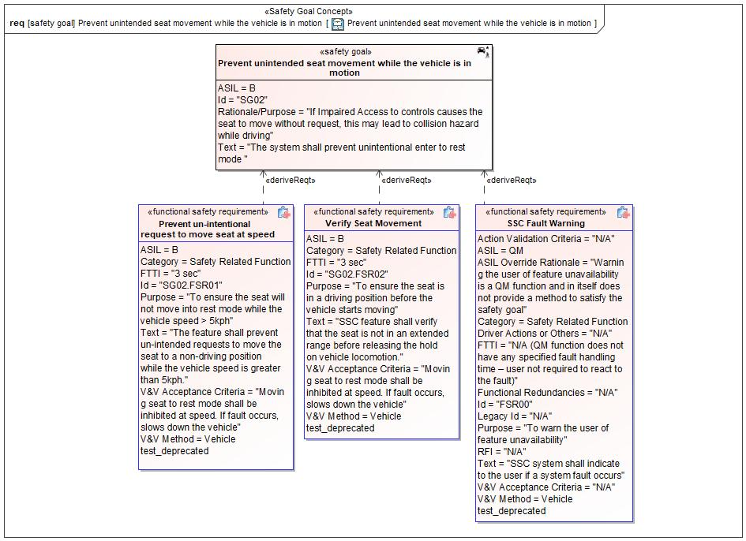

Figure 1: Prevent unintended seat movement while the vehicle is in motion – Prevent unintended seat movement while the vehicle is in motion

*Note: The authoritative source for the Safety Goals is document “FFSD 02 Hazard Analysis* *and Risk Assessment”. The documentation of Safety Goals in this chapter (In the Argumentation for Safety Goal achievement) is for information purposes only.*

*The authoritative source for the Functional Safety Requirements is section 2.1.x.3: of this document. The documentation of Functional Safety Requirements in the following chapter (complete or summarised) is for information purposes only.*

#### Warning and Recovery Concept

No Warning and Recovery Concept diagram specified.

#### Functional Safety Requirements without Dedicated Diagram

**#Hint:** The following Functional Safety Requirements are not depicted on dedicated requirements diagrams and are therefore all listed here.

FSR00 SSC Fault Warning

*Please see the Functional Safety Requirement table for* *SSC Fault Warning* *displayed under the Safety Goal SG01.*

SG01.FSR01 Steering Column Shall Not Stow While Vehicle in Motion

*Please see the Functional Safety Requirement table for* *Steering Column Shall Not Stow While Vehicle in Motion* *displayed under the Safety Goal SG01.*

SG01.FSR02 Deploy the Steering Column in Motive Mode When Requested by the User

*Please see the Functional Safety Requirement table for*  *Deploy the Steering Column in Motive Mode When Requested by the User* *displayed under the Safety Goal SG01.*

SG02.FSR01 Prevent un-intentional request to move seat at speed

The feature shall prevent un-intended requests to move the seat to a non-driving position while the vehicle speed is greater than 5kph.

Satisfied by:

* Logicals:
  + Driver Seat System
  + Stowable Feature Controller
  + Stowable Steering and Deployable Tray Feature

Related to:

* Safe States:
  + Feature Inhibited
* Operating Modes:
  + Idle

|  |  |  |  |  |  |  |  |
| --- | --- | --- | --- | --- | --- | --- | --- |
| Requirement ID: SG02.FSR01 | | | | | | | |
| **Purpose** | To ensure the seat will not move into rest mode while the vehicle speed > 5kph | | | | | | |
| **V&V Acceptance Criteria** | Moving seat to rest mode shall be inhibited at speed. If fault occurs, slows down the vehicle | | | | | | |
| **Notes** |  | | | | | | |
| **Source** |  | | | | | **Owner** |  |
| **Source Req.** | * -831088419.jpg SG02 Prevent unintended seat movement while the vehicle is in motion | | | | | **V&V Method** | Vehicle test_deprecated |
| **Type** | N/A | | **Priority** | | N/A | **Status** |  |
| **ASIL** | B | | **Category** | | Safety Related Function | **Fault Handling Time** | N/A |
| [Req. Template](http://wiki.ford.com/display/RequirementsEngineering/Requirements+Attributes) Version | | 6.0 | | End of Requirement | | | |

SG02.FSR02 Verify Seat Movement

SSC feature shall verify that the seat is not in an extended range before releasing the hold on vehicle locomotion.

Satisfied by:

* Logicals:
  + Driver Seat System
  + Stowable Feature Controller
  + Stowable Steering and Deployable Tray Feature

Related to:

* Safe States:
  + Fault Mode
  + Feature Inhibited
* Operating Modes:
  + Idle

|  |  |  |  |  |  |  |  |
| --- | --- | --- | --- | --- | --- | --- | --- |
| Requirement ID: SG02.FSR02 | | | | | | | |
| **Purpose** | To ensure the seat is in a driving position before the vehicle starts moving | | | | | | |
| **V&V Acceptance Criteria** | Moving seat to rest mode shall be inhibited at speed. If fault occurs, slows down the vehicle | | | | | | |
| **Notes** |  | | | | | | |
| **Source** |  | | | | | **Owner** |  |
| **Source Req.** | * -831088419.jpg SG02 Prevent unintended seat movement while the vehicle is in motion | | | | | **V&V Method** | Vehicle test_deprecated |
| **Type** | N/A | | **Priority** | | N/A | **Status** |  |
| **ASIL** | B | | **Category** | | Safety Related Function | **Fault Handling Time** | N/A |
| [Req. Template](http://wiki.ford.com/display/RequirementsEngineering/Requirements+Attributes) Version | | 6.0 | | End of Requirement | | | |

### Derivation of Functional Safety Requirements on Assumptions

**#Classification**: Functional Safety only

**#Hint:** Derive requirements from the Assumptions (refer to section “Safety Assumptions”

No Functional Safety Requirements tracing to Assumptions specified.

## ASIL Decomposition of Functional Safety Requirements

***#Classification:*** *Functional Safety Only*

***#Hint:*** *For ASIL D features additional measures like a requirements decomposition might be required. Fill out the following table for each ASIL D decomposition applied in the feature. The decomposition rationale is the reason why the decomposition was performed, whereas the rationale for each requirement expresses the reason and thought behind that particular requirement and should include how the requirement is able to independently fulfill the needs of the parent requirement.*

***#Link:***[*Functional Safety Sharepoint*](https://pd3.spt.ford.com/sites/GlobalFunctionalSafety/Pages/default.aspx) *- Functional Safety Concept*

No Functional Safety Requirements with ASIL Decompositions specified.

# Architecture

## Functional Architecture

**#Classification:** Mandatory for Functional Safety – otherwise optional

**#Hint**: This section depicts the coarse Functional Architecture. This architectural step is needed to find the right functional partitioning for the function level. The function shown here are those, which are specified on function level. Either SysML activity diagrams or Data Flow Diagrams could be used to depict such a Functional Architecture. For bigger features, which are decomposed in a hierarchical manner down to atomic functions (and which do not follow the Functional Safety process), a function tree could be given here.

**#Links:**

* Functional Decomposition: [RE Wiki – Functional Decomposition](http://wiki.ford.com/display/RequirementsEngineering/Functional+Decomposition)
* SysML - Activity Diagrams or [RE Wiki - Data Flow Diagrams](http://wiki.ford.com/display/RequirementsEngineering/Data+Flow+Diagram?src=contextnavpagetreemodehttp://wiki.ford.com/display/RequirementsEngineering/Data+Flow+Diagram?src=contextnavpagetreemode)
* Data Flow Diagram: [RE Wiki – Data Flow Diagram](http://wiki.ford.com/display/RequirementsEngineering/Functional+Decomposition)

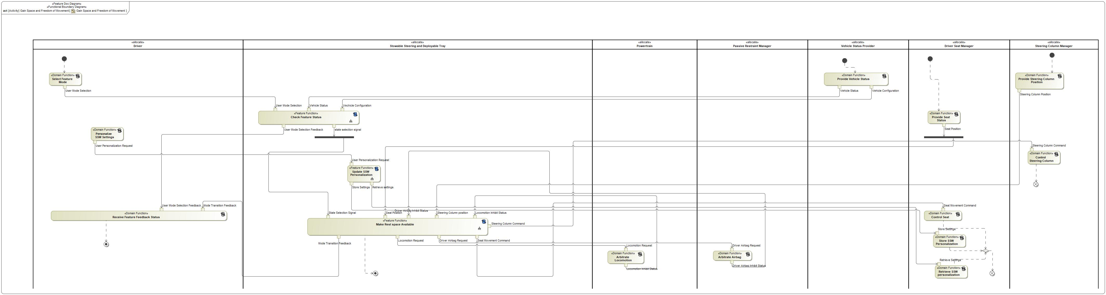

Figure 8: Gain Space and Freedom of Movement

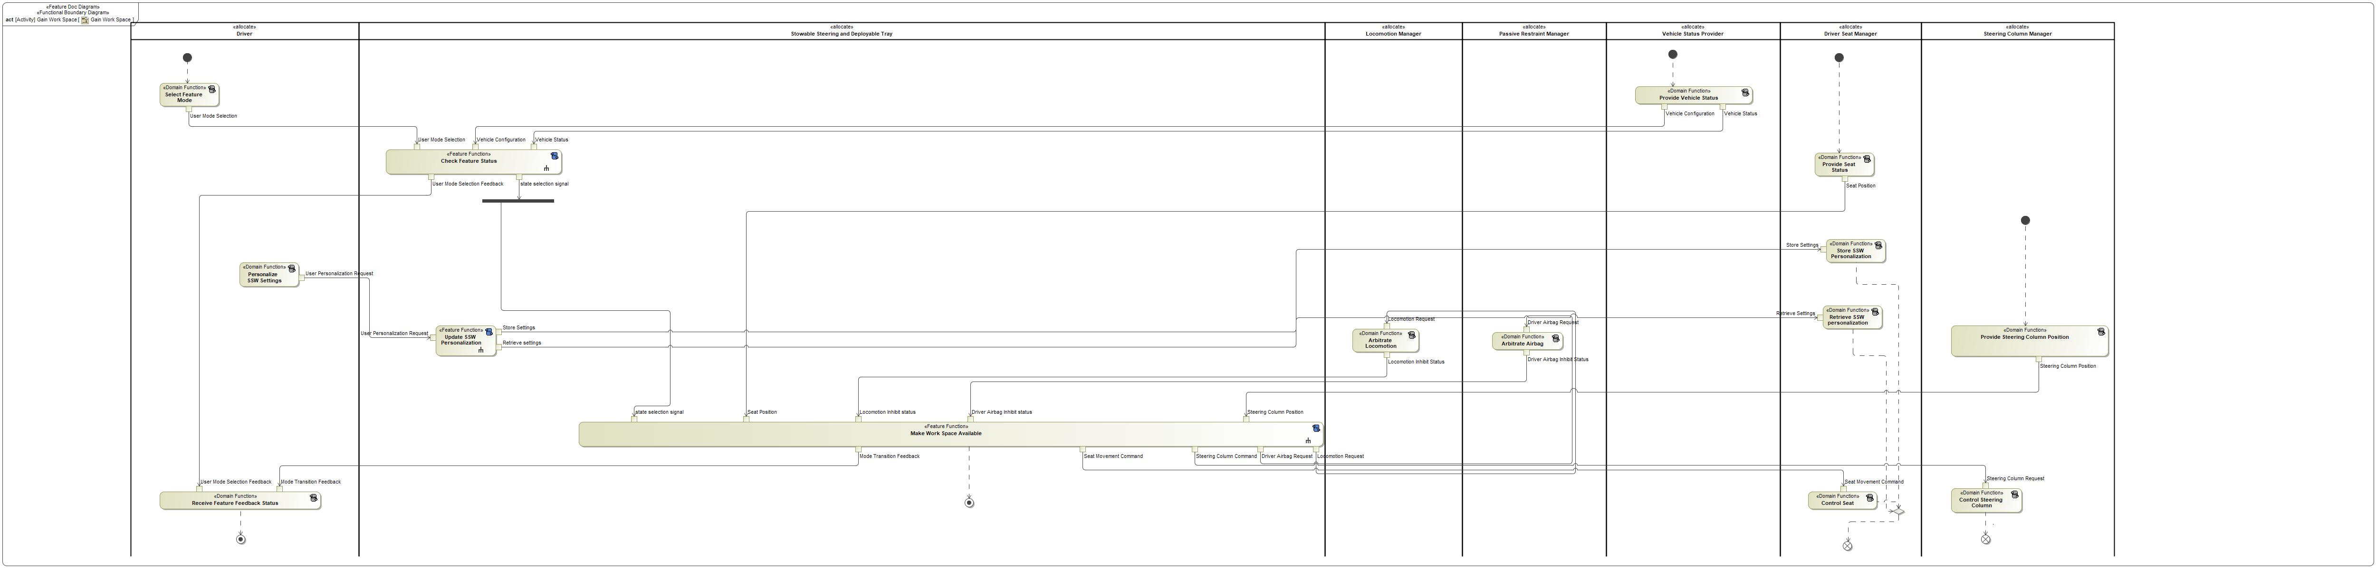

Figure 8: Gain Work Space

### List of Functions

**#Hint:** The functions shown in the Functional Architecture should be listed and described in the table below

| **Function Name** | Description | Comments |
| --- | --- | --- |
| *(activity)* Arbitrate Airbag | *(activity)* This Function receives the Airbag requests and Arbitrate the Airbag Accordingly and sends out the Airbag Inhibit Status |  |
| *(activity)* Select Feature Mode | *(activity)* A Domain Function of HMI which is responsible for Accepting User Input and send it to the Feature |  |
| *(activity)* Provide Steering Column Position | *(activity)* Steering Column system providing Feature the current Steering Column Position |  |
| *(activity)* Personalize SSW Settings | *(activity)* Domain function responsible for Driver Personalizing the seat and steering column memory positions |  |
| *(activity)* Provide Vehicle Status | *(activity)* A Domain Function which provides the Vehicle status to the Feature |  |
| *(activity)* Retrieve SSW personalization | *(activity)* Retrieve SSW settings that Driver saved earlier |  |
| *(activity)* Store SSW Personalization | *(activity)* A Domain function responsible for storing settings selected by the Driver |  |
| *(activity)* Control Steering Column | *(activity)* A domain function which is responsible for moving the steering column as requested by Feature |  |
| *(activity)* Receive Feature Feedback Status | *(activity)* A Domain Function of HMI which is responsible for Displaying Modes, Status to the User |  |
| *(activity)* Update SSW Personalization |  |  |
| *(activity)* Arbitrate Locomotion | *(activity)* A Domain Function of Powertrain which is responsible to disable the Locomotion |  |
| *(activity)* Check Feature Status | *(activity)* A Feature Function Which Receives and checks the feature status and send state selection signal to the Feature |  |
| *(activity)* Make Rest space Available | *(activity)* A Feature Function which Allows the User to gain Rest Space and gives him the freedom to move |  |
| *(activity)* Provide Seat Status | *(activity)* A Domain Function which provides the Seat position to the Feature |  |
| *(activity)* Control Seat | *(activity)* A Domain Function Which Actuate the Seat based on the Input Requests |  |

Table 17: List of Functions on Gain Space and Freedom of Movement

| **Function Name** | Description | Comments |
| --- | --- | --- |
| *(activity)* Arbitrate Locomotion | *(activity)* A Domain Function of Powertrain which is responsible to disable the Locomotion |  |
| *(activity)* Store SSW Personalization | *(activity)* A Domain function responsible for storing settings selected by the Driver |  |
| *(activity)* Update SSW Personalization |  |  |
| *(activity)* Control Steering Column | *(activity)* A domain function which is responsible for moving the steering column as requested by Feature |  |
| *(activity)* Receive Feature Feedback Status | *(activity)* A Domain Function of HMI which is responsible for Displaying Modes, Status to the User |  |
| *(activity)* Select Feature Mode | *(activity)* A Domain Function of HMI which is responsible for Accepting User Input and send it to the Feature |  |
| *(activity)* Provide Seat Status | *(activity)* A Domain Function which provides the Seat position to the Feature |  |
| *(activity)* Retrieve SSW personalization | *(activity)* Retrieve SSW settings that Driver saved earlier |  |
| *(activity)* Check Feature Status | *(activity)* A Feature Function Which Receives and checks the feature status and send state selection signal to the Feature |  |
| *(activity)* Make Work Space Available | *(activity)* A Feature Function which Allows the User to gain Work Space. |  |
| *(activity)* Arbitrate Airbag | *(activity)* This Function receives the Airbag requests and Arbitrate the Airbag Accordingly and sends out the Airbag Inhibit Status |  |
| *(activity)* Control Seat | *(activity)* A Domain Function Which Actuate the Seat based on the Input Requests |  |
| *(activity)* Personalize SSW Settings | *(activity)* Domain function responsible for Driver Personalizing the seat and steering column memory positions |  |
| *(activity)* Provide Steering Column Position | *(activity)* Steering Column system providing Feature the current Steering Column Position |  |
| *(activity)* Provide Vehicle Status | *(activity)* A Domain Function which provides the Vehicle status to the Feature |  |

Table 17: List of Functions on Gain Work Space

## Logical Architecture

**#Classification:** Functional Safety Analysis only

**#Hint:** FS Analysis requires a description of the boundary of the feature and its elements. A simple block diagram or a SysML Internal Block Diagram could be used to depict the Logical Architecture

***#Link:*** [*Ford Functional Safety Sharepoint*](https://pd3.spt.ford.com/sites/GlobalFunctionalSafety/Pages/default.aspx)

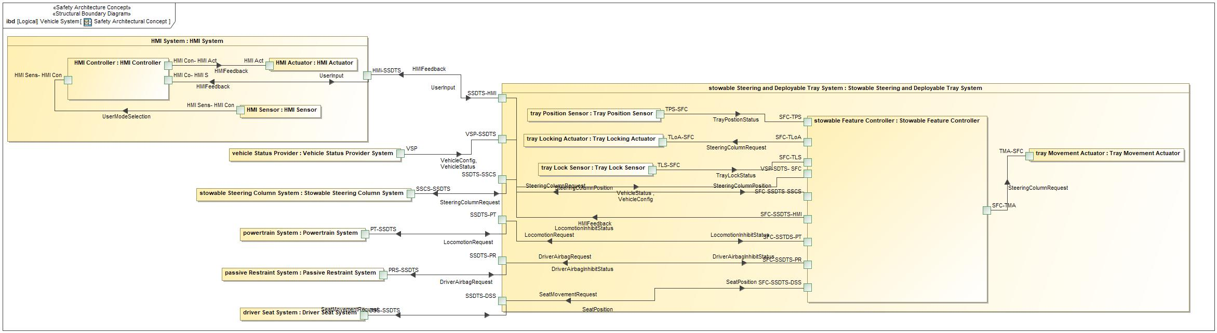

Figure 9: Safety Architectural Concept

### Logical Elements

**#Hint:** Lists the elements of the Logical Architecture and the functions from the Functional Architecture, which are allocated to those elements.

|  |  |  |  |
| --- | --- | --- | --- |
| **Element Name** | **Description** | **Allocated Functions** | **Comments** |
| HMI Actuator |  |  |  |
| HMI Sensor |  |  |  |

Table 19: Logical Elements

### Logical Interfaces

**#Hint:** Describe the interactions of the feature with other features or elements.

|  |  |  |  |
| --- | --- | --- | --- |
| **Interface** | **Direction** | **Description** | **Value Range** |
| DriverAirbagInhibitStatus | PRS-SSDTS (Passive Restraint System) To SSDTS-PR (Stowable Steering and Deployable Tray System) | Status of the Driver Airbag Inhibition |  |
| SSDTS-PR (Stowable Steering and Deployable Tray System) To SFC-SSDTS-PR (Stowable Feature Controller) | Status of the Driver Airbag Inhibition |  |
| DriverAirbagRequest | SFC-SSDTS-PR (Stowable Feature Controller) To SSDTS-PR (Stowable Steering and Deployable Tray System) | Request sent to the Driver Airbag system / Passive Restraint System for either Inhibit or Deinhibit |  |
| SSDTS-PR (Stowable Steering and Deployable Tray System) To PRS-SSDTS (Passive Restraint System) | Request sent to the Driver Airbag system / Passive Restraint System for either Inhibit or Deinhibit |  |
| HMIFeedback | HMI Con- HMI Act (HMI Controller) To HMI Act (HMI Actuator) | Feedback given to HMI |  |
| HMI-SSDTS (HMI System) To HMI Co- HMI S (HMI Controller) | Feedback given to HMI |  |
| SFC-SSDTS-HMI (Stowable Feature Controller) To SSDTS-HMI (Stowable Steering and Deployable Tray System) | Feedback given to HMI |  |
| SSDTS-HMI (Stowable Steering and Deployable Tray System) To HMI-SSDTS (HMI System) | Feedback given to HMI |  |
| LocomotionInhibitStatus | PT-SSDTS (Powertrain System) To SSDTS-PT (Stowable Steering and Deployable Tray System) | Status of the Locomotion Inhibition |  |
| SSDTS-PT (Stowable Steering and Deployable Tray System) To SFC-SSTDS-PT (Stowable Feature Controller) | Status of the Locomotion Inhibition |  |
| LocomotionRequest | SFC-SSTDS-PT (Stowable Feature Controller) To SSDTS-PT (Stowable Steering and Deployable Tray System) | Request to Powertrain / Locomotion to Inhibit /Deinhibit |  |
| SSDTS-PT (Stowable Steering and Deployable Tray System) To PT-SSDTS (Powertrain System) | Request to Powertrain / Locomotion to Inhibit /Deinhibit |  |
| SeatMovementRequest | SFC-SSDTS-DSS (Stowable Feature Controller) To SSDTS-DSS (Stowable Steering and Deployable Tray System) | Command to Move seat which goes to the Driver seat System |  |
| SSDTS-DSS (Stowable Steering and Deployable Tray System) To DSS-SSDTS (Driver Seat System) | Command to Move seat which goes to the Driver seat System |  |
| SeatPosition | DSS-SSDTS (Driver Seat System) To SSDTS-DSS (Stowable Steering and Deployable Tray System) | Current Seat Position from the Driver Seat System |  |
| SSDTS-DSS (Stowable Steering and Deployable Tray System) To SFC-SSDTS-DSS (Stowable Feature Controller) | Current Seat Position from the Driver Seat System |  |
| SteeringColumnPosition | SSCS-SSDTS (Stowable Steering Column System) To SSDTS-SSCS (Stowable Steering and Deployable Tray System) | Position of the Steering Column provided by the steering column system |  |
| SSDTS-SSCS (Stowable Steering and Deployable Tray System) To SFC-SSDTS-SSCS (Stowable Feature Controller) | Position of the Steering Column provided by the steering column system |  |
| SteeringColumnRequest | SFC-SSDTS-SSCS (Stowable Feature Controller) To SSDTS-SSCS (Stowable Steering and Deployable Tray System) | Request to Move steering Column with respect to selected Mode |  |
| SFC-TLoA (Stowable Feature Controller) To TLoA-SFC (Tray Locking Actuator) | Request to Move steering Column with respect to selected Mode |  |
| SFC-TMA (Stowable Feature Controller) To TMA-SFC (Tray Movement Actuator) | Request to Move steering Column with respect to selected Mode |  |
| SSDTS-SSCS (Stowable Steering and Deployable Tray System) To SSCS-SSDTS (Stowable Steering Column System) | Request to Move steering Column with respect to selected Mode |  |
| TrayLockStatus | TLS-SFC (Tray Lock Sensor) To SFC-TLS (Stowable Feature Controller) | Tray lock status is given by Tray Lock sensor |  |
| TrayPostionStatus | TPS-SFC (Tray Position Sensor) To SFC-TPS (Stowable Feature Controller) | Tray Position status is the feedback for Tray position given by Tray position Sensor |  |
| UserInput | HMI Co- HMI S (HMI Controller) To HMI-SSDTS (HMI System) | Input given by user through HMI |  |
| HMI-SSDTS (HMI System) To SSDTS-HMI (Stowable Steering and Deployable Tray System) | Input given by user through HMI |  |
| UserModeSelection | HMI Sens- HMI Con (HMI Sensor) To HMI Sens- HMI Con (HMI Controller) | Mode selection information from User |  |
| VehicleConfig | VSP (Vehicle Status Provider System) To VSP-SSDTS (Stowable Steering and Deployable Tray System) | Configuration of the Feature and Vehicle Specific |  |
| VSP-SSDTS (Stowable Steering and Deployable Tray System) To VSP-SDTS- SFC (Stowable Feature Controller) | Configuration of the Feature and Vehicle Specific |  |
| VehicleStatus | VSP (Vehicle Status Provider System) To VSP-SSDTS (Stowable Steering and Deployable Tray System) | This Signal is the collectivity approval signal which includes Parking status, battery state of charge and Vehicle Speed |  |
| VSP-SSDTS (Stowable Steering and Deployable Tray System) To VSP-SDTS- SFC (Stowable Feature Controller) | This Signal is the collectivity approval signal which includes Parking status, battery state of charge and Vehicle Speed |  |

Table 18: Feature Interactions

# Open Concerns

**#Hint:** The following list presents open concerns, which have to be discussed or clarified over the course of the on-going requirements engineering.

| ID | Concern Description | e-Tracker / Reference | Responsible | Status | Solution |
| --- | --- | --- | --- | --- | --- |
| 1 |  |  |  |  |  |

Table 20: Open Concerns *(Not supported by MagicDraw report generation)*

# Revision History

**#Hint:** A new version number is assigned to a document with a given revision each time it is checked in to Team Center (TCSE). After release of a revision, the document cannot be edited and no new versions can be created on that revision. When updating the document after that, a new revision has to be created and new versions on that revision will be created upon checking in.

No Revision History found.

## Template Revisions

*#Important: Do not change this section*

|  |  |  |  |  |
| --- | --- | --- | --- | --- |
| Version | Rev. | Date | Description | Responsible |
| *0* | *6* | *2015-05-26* | * *Chapter “Feature Overview” and made a 2nd level heading.* * *Chapter “Feature Modeling” divided into 3 subchapter (“Scenarios”, “Use Cases”, “State Machines”) for different modeling methods* | *Jbaden1* |
| *0* | *7* | *2015-05-27* | * *Table of Content updated* * *Template Revision History chapter added* | *Jbaden1* |
| *0* | *8* | *2015-07-02* | * *Section “Unsettled Issues” added* | *Alevin7* |
| *0* | *9* | *2015-08-04* | * *Section “Feature Variants” added* * *Section “Feature Boundary Diagram” renamed to “Feature Context Diagram”* * *Document Properties adapted to match needs of VBA macros* | *Jbaden1, Awegman1* |
| *1* | *0* | *2015-09-11* | * *Section “Feature Variants” reworked* * *Feature Goals removed. Only “Safety Goals“ chapter remains.* * *Heading 2 formatting issues corrected.* * *Requirements / Use Cases Listing removed from traceability chapter.* * *Formatting of attribute table in Notation chapter corrected* * *Open Topics / Known Issues chapter moved to the end* | *Jbaden1* |
| *1* | *1* | *2015-11-16* | * *Table-Styles removed (for smooth VSEM import)* * *Some clean-up of sections “Purpose” and “Audience”* | *Awegman1, jbaden1* |
| *1* | *2* | *2016-02-26* | * *Minor corrections based on lessons learned from CC and PCL pilot (e.g. section market/regions) and discussion with Functional Safety Team (purpose of feature)* * *Footer corrected* * *Boundary diagram interface chapter renamed to influences.* | *Jbaden1* |
| *1* | *3* | *2016-02-26* | * *Minor corrections after review with Whitney Keith from Functional Safety team* | *Jbaden1* |
| *1* | *4* | *2016-03-10* | * *Some cleanup of meta-data in Word Properties* | *Jbaden1* |
| *1* | *5* | *2016-03-10* | * *Footer formatting corrected (Issue 19)* * *Results from review with Functional Safety Team incorporated (Issue 20).* | *jbaden1* |
| *1* | *6* | *2016-04-18* | * *Scenario Template added* | *Jbaden1* |
| *1* | *7* | *2016-04-18* | * *Chapter “Operation Modes and States” moved before “Use Case” section.* | *Jbaden1* |
| *1* | *8* | *2016-04-18* | * *Broken Wiki links repaired.* | *Jbaden1* |
| *2* | *0* | *2016-05-19* | * *Adapted to Specification_Macros.dotm V2.0* * *Requirements Templates chapter (ch. 1.7.1) no longer has an attribute table, but refers directly to the Wiki..* | *Jbaden1* |
| *2* | *1* | *2016-06-10* | * *Table for Context Diagram modified (lists external entities and Influence Description only)* | *Jbaden1* |
| *2* | *2* | *2016-07-08* | * *Template version added to footer* * *Several hints added to the various sections* * *Findings from Functional Safety Team incorporated.* * *RE_SafetyRequirement style added* | *Jbaden1* |
| *2* | *3* | *2016-09-21* | * *Update from Functional Safety Team incorporated (“Lessons Learned”, “System Behaviors for HARA”)* | *Jbaden1* |
| *2* | *4* | *2016-11-15* | * *Update from Functional Safety Team incorporated (“Lessons Learned”, “System Behaviors for HARA”)* * *Explanatory notes made more formal* | *Jbaden1* |
| *3* |  |  | *Skipped to synchronize with Specification_Macros.dotm* |  |
| *4* |  |
| *5* | *0* | *2017-01-13* | * *Meta data updated for specification macros, version 3.1* * *SW Unit chapter removed for the time being* * *Green boxes added for user hints* | *Jbaden1* |
| *5* | *1* | *2017-01-18* | * *Minor editorial changes* | *Jbaden1* |
| *6* | *0* | *2017-02-03* | * *CR48: Chapter 6 renamed from “Safety” to “Functional Safety”. New sub-chapter “Safety” introduced in Non-Functional Requirements section* | *Jbaden1* |
| *6* | *0* | *2017-04-28* | * *CR7: “RequirementsTraceability” chapter removed* | *Jbaden1* |
| *6* | *0* | *2017-11-15* | * *CR32/53: New Cover Sheet + Disclaimer replaces FAP-150 like ones.* * *CR75: Some rewording -> Terminology to Glossary, Notation -> Document Conventions* * *CR49: Rename “Assumptions & Constraints” to “Assumptions”* * *CR74: Safety Assumptions added to chapter 6.* * *CR58: Add function allocation column to Logical Architecture chapter* | *Jbaden1* |
| *6* | *0* | *2018-01-31* | * *CR63: Updated links to Functional Safety Sharepoint* | *Jbaden1* |
| *6* | *0* | *2018-07-24* | * *CR69: Add FSR to FeatureDoc* * *CR64: Add new section "Design Requirements" to Function Spec and Feature Spec* | *Jbaden1* |
| *6* | *0* | *2018-08-06* | * *CR53: some corrections for metada and formatting* | *Jbaden1* |
| *6* | *0* | *2018-09-28* | * *Broken links to RE Wiki repaired* | *Jbaden1* |
| *6* | *0* | *2018-10-31* | * *Cover sheet and footer more GIS like. Functional Safety team feedback incorporated:*   + *New subsections “Functional Safety Requirements, (Decomposed) FSRs and Parameters / Values*   + *Removal of “Logical Architecture”* | *Jbaden1* |
| *6* | *0* | *2018-12-12* | * *FSR template removed, now as a macro in the Specification_Macros.dotm* | *Jbaden1* |
| *N* |  | *2019-04-03* | * *Updated code for context diagrams, actors and use cases.* * *Updated code structure with all macros at the beginning.* * *Updated code to populate assumptions using element-assumption relationship or hazardous event.* | *snuesch* |
| *N* |  | *2019-04-18* | * *Added structural boundary diagram for FuSa based on TGB discussion.* * *Added operating modes to functional safety requirements.* | *snuesch* |
| *O* |  | *2019-04-25* | * *Improved export of actions and activities on functional boundary diagram.* | *snuesch* |
| *6* | *0b* | *2019-05-23* | * *Re-introduce “Logical Architecture” (for Functional Safety)* | *Jbaden1* |
| *O* |  | *2019-06-17* | * *Aligned “Architecture” section with RE template.* * *Made “Ford Documents” table more flexible.* * *Added template terms to glossary* | *snuesch* |
| *O* |  | *2019-06-25* | * *Improved use cases to handle Primary and Secondary actors.* * *Added Performance Requirements to Uncategorized.* | *snuesch* |
| *6* | *0b* | *2019-06-26* | * *Chapter “Logical Elements” in “Logical Architecture” section added (FuSa CR 15136240)* * *“References” and “Glossary” chapter moved from section “Feature Overview” to “Introduction”. References and Glossary should be available in the document as early as possible* | *Jbaden1* |
| *O* |  | *2019-07-25* | * *Added populated “Logical Elements” table and allocated functions.* * *Export documentation field of context diagram.* | *snuesch* |

# Appendix

## Definitions

| **Definition** | **Description** |
| --- | --- |
| Deploy | Come out / Move away from Dashboard or Instrument Panel Cluster |
| Drivability Status | Status to make sure all the component's status are good before allowing the drivability to user for safe drive |
| Drive Control | Drive Control is the Control status of Locomotion and Passive Restraint ( Drive Airbag)) |
| High speed | Approximately more than 52 mph (83 kph) |
| Stow | Move in / Move towards to Dashboard or Instrument Panel Cluster |
| Tray | Work surface where a User / Driver can use |

Table 21: Definitions used in this document

## Abbreviations

No acronyms specified.

Document ends here.